**Chapter 1**

1. **INTRODUCTION** 
   1. **OVERVIEW**

Database is a collection of related data and data is a collection of facts and figures that can be processed to produce information. Mostly data represents recordable facts. Data aids in producing information, which is based on facts. A database management system stores data in such a way that it becomes easier to retrieve, manipulate, and produce information. Database is actually a place where related piece of information is stored and various operations can be performed on it. DBMS is actually a tool used to perform any kind of operation on data in database. DBMS also provides protection and security to database. It maintains data consistency in case of multiple users. Examples of DBMS are SQL, Oracle, Sybase etc.

The database system can be divided into four components:

**Hardware**: The hardware is the actual computer system used for keeping and accessing the database. The conventional DBMS hardware consists of secondary storage devices such as hard disks. Databases run on the range of machines from microcomputers to mainframes.

**Software**: Software is the actual DBMS between the physical database and the users of the system. All the requests from the user for accessing the database are handled by DBMS.

**Data**: It is an important component of the database management system. The main task of DBMS is to process the data. Databases are used to store the data, retrieved, and updated to and from the databases.

**Users**: There are a number of users who can access the data on demand using the application and the interfaces provided by the DBMS. Database Languages are the set of statements that are used to define and manipulate a database. Data Definition Language (DDL) is used to construct a database & Data Manipulation Language (DML) is used to access a database.

Functions of DBMS:

* Provides backup and recovery services
* Provides utility
* Provides data Independence
* Provides clear logical view of manipulated data
* Security and Integrity

Advantages of DBMS:

* Segregation of application program
* Minimal data duplicity
* Reduced development time and maintenance need
* Easy retrieval of data
* Increased end user productivity
  1. **PROBLEM STATEMENT**

Currently, crucial information is managed and maintained manually by laundry companies. With data repositories dispersed throughout the laundry management infrastructure, the existing method necessitates several paper forms. Information is frequently unfinished or does not adhere to management standards. Records are frequently lost in transit during computation, necessitating a thorough auditing process that takes a lot of time to guarantee that no crucial information is lost. The laundry company's data contains many copies of the same information, which could cause discrepancies in the data across different data storage. A significant part of the operation of any laundry firm involves the management and timely retrieval of great volumes of information including customer personal information and clothing records history price of delivery and received date etc. Any laundry business' functioning includes managing and promptly retrieving enormous amounts of information, including client personal data, clothes records, history prices, shipping and receipt dates, etc. Thus I have designed a laundry management database system used in a laundry establishment whose aim is to maintain all user and employee information in a designed manner, keep a record of all transactions and billings and determine the amount of garments collected in relation to their owners since this aids users in deciding when to have their garments collected.

* 1. **OBJECTIVES**

1. The aim of this project is to develop a system that can handle and manage the activities involved in a laundry in an efficient and reliable way. The objectives for this project are:
2. Automated System: The suggested solution will use a computerised system that can manage the laundry process more effectively. The customer's and the laundry service's data will be preserved without any issues with data loss.

* System privileges and user rights: In the proposed system, system and user privileges will be established to set up the user level for each system user. The purpose of this function is to limit system access.
* Improve time efficiency: For the laundry management to ensure that the service operates in better condition and on time, time management is crucial. Additionally, the business process will be quicker and more efficient by employing the computerised system.
  1. **DATASET DESCRIPTION**
* CUSTOMER TABLE

|  |  |  |  |
| --- | --- | --- | --- |
| Field Name | Description | Type | Length |
| CID | Customer ID | int | 5 |
| CNAME | Customer Name | varchar | 30 |
| CADDRESS | Customer Address | varchar | 100 |
| PHN | Customer Phone Number | varchar | 10 |
| GENDER | Customer gender | char | 5 |

Table 1.4.1- Customer Table

* EMPLOYEE TABLE

|  |  |  |  |
| --- | --- | --- | --- |
| Field Name | Description | Type | Length |
| EID | Employee ID | int | 5 |
| ENAME | Employee Name | varchar | 30 |
| EADDRESS | Employee Address | varchar | 100 |
| EPHN | Employee Phone Number | varchar | 10 |

Table 1.4.2-Employee Table

* SERVICES TABLE

|  |  |  |  |
| --- | --- | --- | --- |
| Field Name | Description | Type | Length |
| SID | Service ID | int | 5 |
| SNAME | Service Name | varchar | 30 |
| SPRICE | Service Price | int | 10 |

Table 1.4.3- Services Table

* BILL TABLE

|  |  |  |  |
| --- | --- | --- | --- |
| Field Name | Description | Type | Length |
| BID | Bill ID | int | 5 |
| CUSID | Customer ID | int | 5 |
| DELID | Delivery ID | int | 5 |
| AMT | Total Amount | int | 10 |
| QNTY | Quantity of clothes | int | 10 |
| SVID | Service ID | int | 10 |

Table 1.4.4- Bill Table

* DELIVERY TABLE

|  |  |  |  |
| --- | --- | --- | --- |
| Field Name | Description | Type | Length |
| DID | Delivery ID | int | 5 |
| CUSTID | Customer ID | int | 5 |
| EMPID | Delivery Employee ID | int | 5 |
| ADDRESS | Delivery Address | varchar | 100 |
| NAME | Recipient Name | varchar | 30 |
| DATE | Delivery Date | varchar | 10 |

Table 1.4.5-Delivery Table

**Chapter 2**

1. **SYSTEM REQUIREMENTS**
   1. **SOFTWARE REQUIREMENTS**

Operating system: Windows 10, 64 bit and XAMPP Server

Front end: HTML AND CSS

Server side language: PHP

Back end: MySql

* 1. **HARDWARE REQUIREMENTS**

Processor: Intel Core i5

Processor Speed: 13 GHZ

Ram Size: 1 GB ram (min)

Minimum Disk Space: 250GB space (min)

**Chapter 3**

1. **SYSTEM DESIGN**
   1. **ER DIAGRAM**

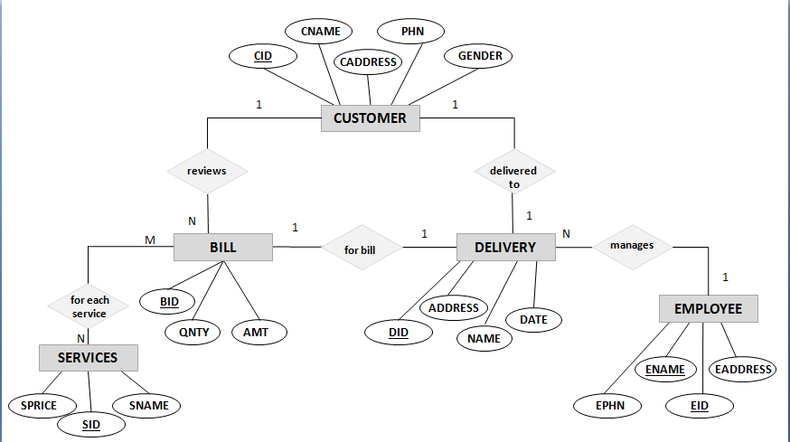

Figure 3.1.1-ER Diagram

* 1. **ER TO RELATION MAPPING**
* Customer refers to Bill with primary key Customer Id using foreign key approach.
* Customer refers to Delivery with primary key Customer Id using foreign key approach.
* Employee refers to Delivery with primary key Employee Id using foreign key approach.
* Services refers to Bill with primary key Service Price using foreign key approach.
* Delivery refers to Bill with primary key Delivery Id using foreign key approach.
  1. **SCHEMA DIAGRAM**

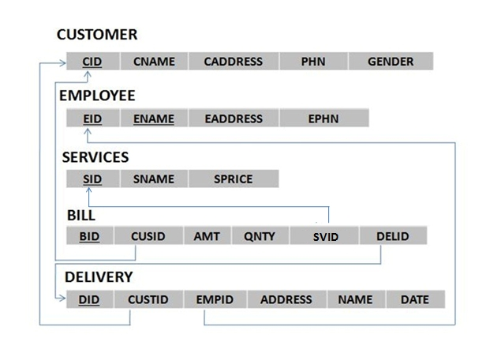

Figure 3.1.2-Schema diagram

* 1. **OVERVIEW OF GUI**

GUI is a program interface that takes advantage of the computer's graphics capabilities to make the program easier to use. A graphical user interface (GUI) is an interface through which a user interacts with electronic devices such as computers and smartphones through the use of icons, menus and other visual indicators or representations (graphics). GUIs graphically display information and related user controls, unlike text-based interfaces, where data and commands are strictly in text. GUI representations are manipulated by a pointing device such as a mouse, trackball, stylus, or by a finger on a touch screen. On the other hand, many users find that they work more effectively with a command-driven interface, especially if they already know the command language. The user interface provided in this project is through HTML and CSS.

* 1. **NORMALIZATION**

Normalization is a process of analysing the given relation schema based on their functional dependencies and primary key to achieve desirable properties of minimizing redundancy and minimizing insert, delete, update anomaly.

Normalization rule are divided into:

**First Normal Form**: It states that the domain of an attribute must include only atomic values and that the value of any attribute in a tuple must be a single value from the domain of attribute..

**Second Normal Form**: It is based on the concept of full functional dependency. A functional dependency X -> Y is a full functional dependency if removal of any attribute A from X means that the dependency does not hold anymore. A relation schema R is in 2NF if every nonprime attribute A in R is fully functionally dependent on the primary key of R.

**Third Normal Form**: It is based on the concept of transitive dependency. A relation schema R is in 3NF if it satisfies 2NF and no nonprime attribute of R is transitively dependent on the primary key. A relation schema R is in 3NF if every nonprime attribute of R meets both of the following conditions:

• It is fully functionally dependent on every key of R.

• It is non-transitively dependent on every key of R.

Normalization of Member Tables:

**Customers**:

FD1: cid->{cname,caddress,phn,gender}

FD2: cname->gender

|  |  |  |  |  |
| --- | --- | --- | --- | --- |
| cid | cname | caddress | phn | gender |

Table 3.5.1 Member Table in INF

It is in INF as it does not have any composite or multivalued attributes.

• It is in 2NF as it is fully functionally dependent.

• (cid) -› (cname,caddress,phn,gender) , (cname)->(gender)

* apart from cid ,cname which is a non key attributr is also determining gender ,so table is not in 3NF.
* To bring it to 3NF we split it and make cname as a primary key

|  |  |  |  |
| --- | --- | --- | --- |
| cid | cname | address | phn |

|  |  |
| --- | --- |
| cname | gender |

Table 3.5.2- Member Table in INF, 2NF, 3NF Table 3.5.3- Member Table in INF, 2NF, 3NF

• As the relations does not contain a non-key attribute functionally determining other non-key

attributes, it is in 3NF (there is no transitivity in attributes).

**Employee**:

FD1: eid->{ename,eaddress,ephn}

|  |  |  |  |
| --- | --- | --- | --- |
| eid | ename | eaddress | ephn |

Table 3.5.4-Member Table in INF, 2NF, 3NF

It is in INF as it does not have any composite or multivalued attributes.

• It is in 2NF as it is fully functionally dependent.

• (eid) -› (ename,eaddress,ephn)

• As the relation does not contain a non-key attribute functionally determining other non-key

attributes, it is in 3NF (there is no transitivity in attributes).

**Services**:

FD1: sid->{sprice,sname}

|  |  |  |
| --- | --- | --- |
| sid | sname | sprice |

Table 3.5.5 Member Table in INF, 2NF, 3NF

It is in INF as it does not have any composite or multivalued attributes.

• It is in 2NF as it is fully functionally dependent.

• (sid) -› (sname,sprice)

• As the relation does not contain a non-key attribute functionally determining other non-key

attributes, it is in 3NF (there is no transitivity in attributes

**Chapter 4**

1. **IMPLEMENTATION**
   1. **TABLE CREATION**

* CREATE TABLE CUSTOMERS (

cid INT(5) NOT NULL,

cname VARCHAR(30),

caddress VARCHAR(100),

phn CHAR(10),

gender CHAR(1),

PRIMARY KEY(cid));

* CREATE TABLE EMPLOYEE (

eid INT(5) NOT NULL,

ename VARCHAR(30),

eaddress VARCHAR(100),

ephn CHAR(10),

PRIMARY KEY(eid));

* CREATE TABLE SERVICES (

sid INT(5) NOT NULL,

sname VARCHAR(30),

sprice INT(11),

PRIMARY KEY(sid));

* CREATE TABLE BILL (

bid INT(5) NOT NULL,

cusid INT(5),

svid INT(11),

qnty INT(5),

amt INT(5),

delid INT(5),

PRIMARY KEY(bid),

FOREIGN KEY(cusid) REFERENCES CUSTOMERS(cid),

FOREIGN KEY(svid) REFERENCES SERVICES(sid),

FOREIGN KEY(delid) REFERENCES DELIVERY(did));

* CREATE TABLE DELIVERY (

did INT(5) NOT NULL,

custid INT(5),

empid INT(5),

name VARCHAR(30),

address VARCHAR(100),

ddate DATE,

PRIMARY KEY(did),

FOREIGN KEY(custid) REFERENCES CUSTOMERS(cid),

FOREIGN KEY(empid) REFERENCES EMPLOYEE(eid));

* 1. **DESCRIPTION OF TABLE**

SQL->Desc customers;

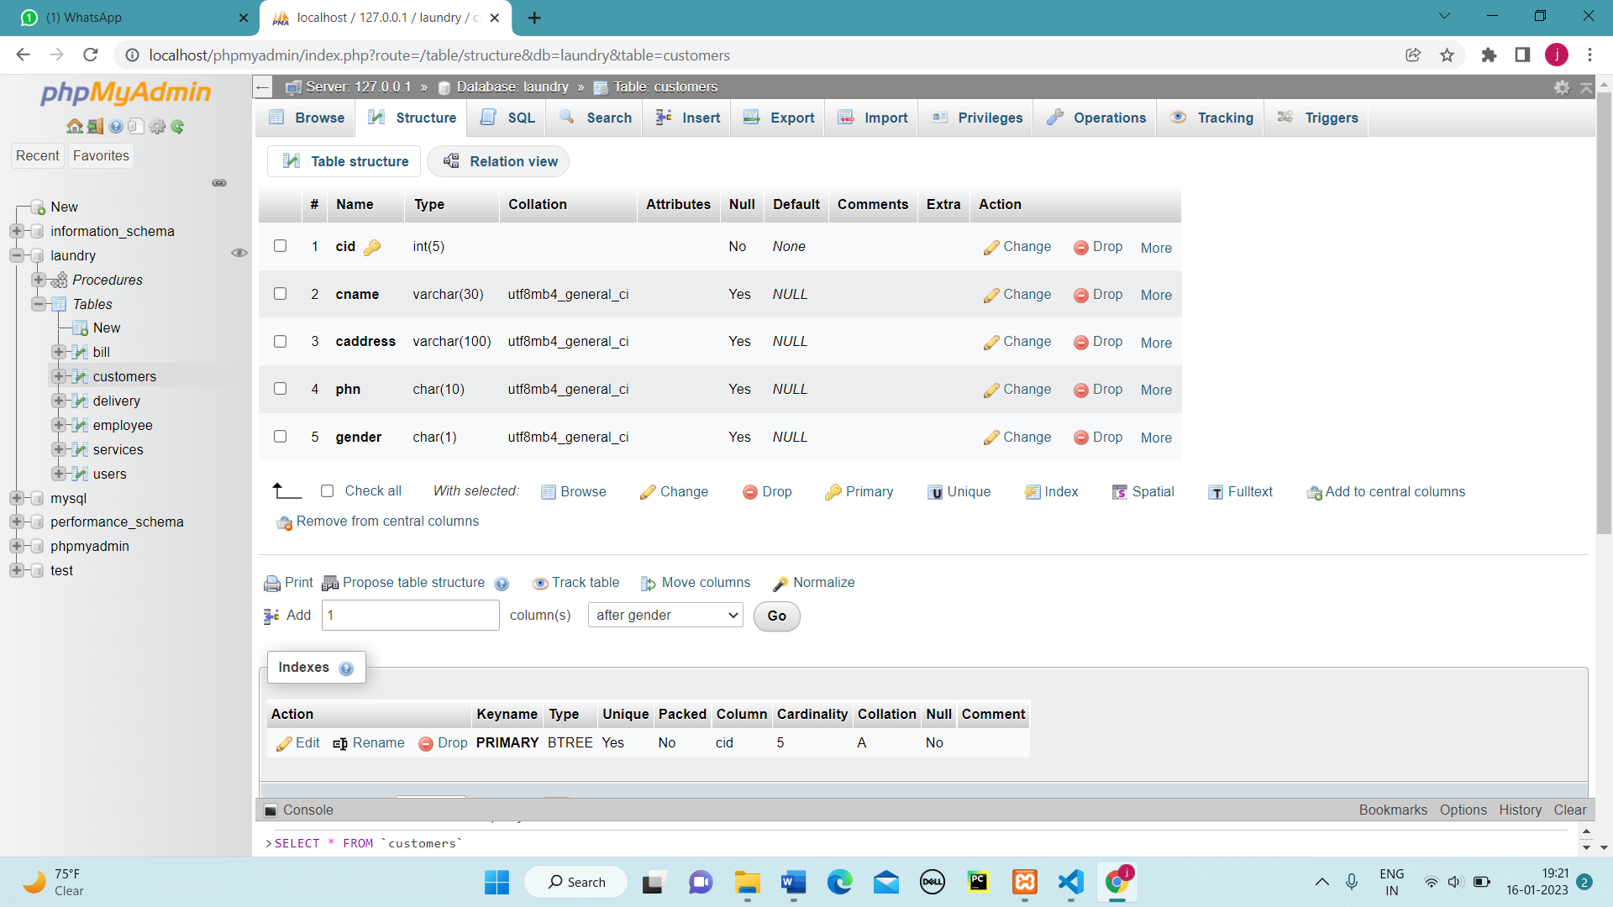

Figure 4.2.4- Description of Customers

SQL->Desc employee;

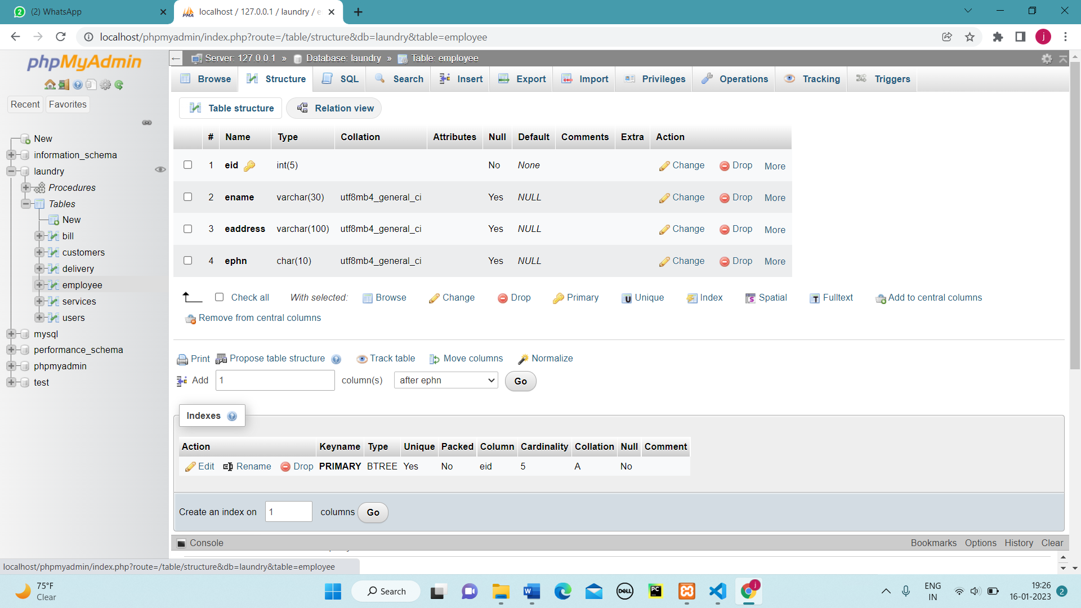

Figure 4.2.2- Description of Employee

SQL->Desc services;

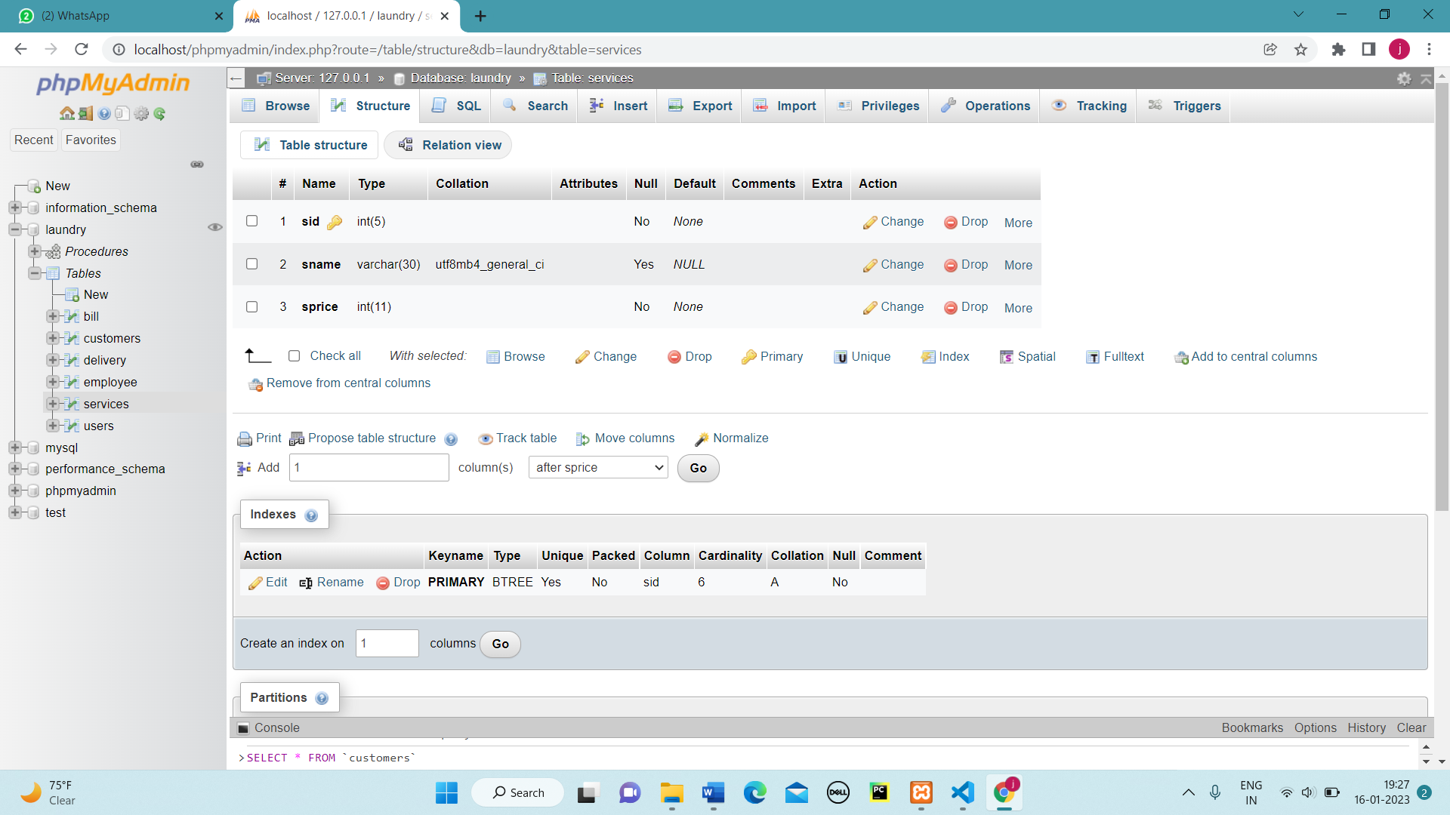

Figure 4.2.3- Description of Services

SQL->Desc bill;

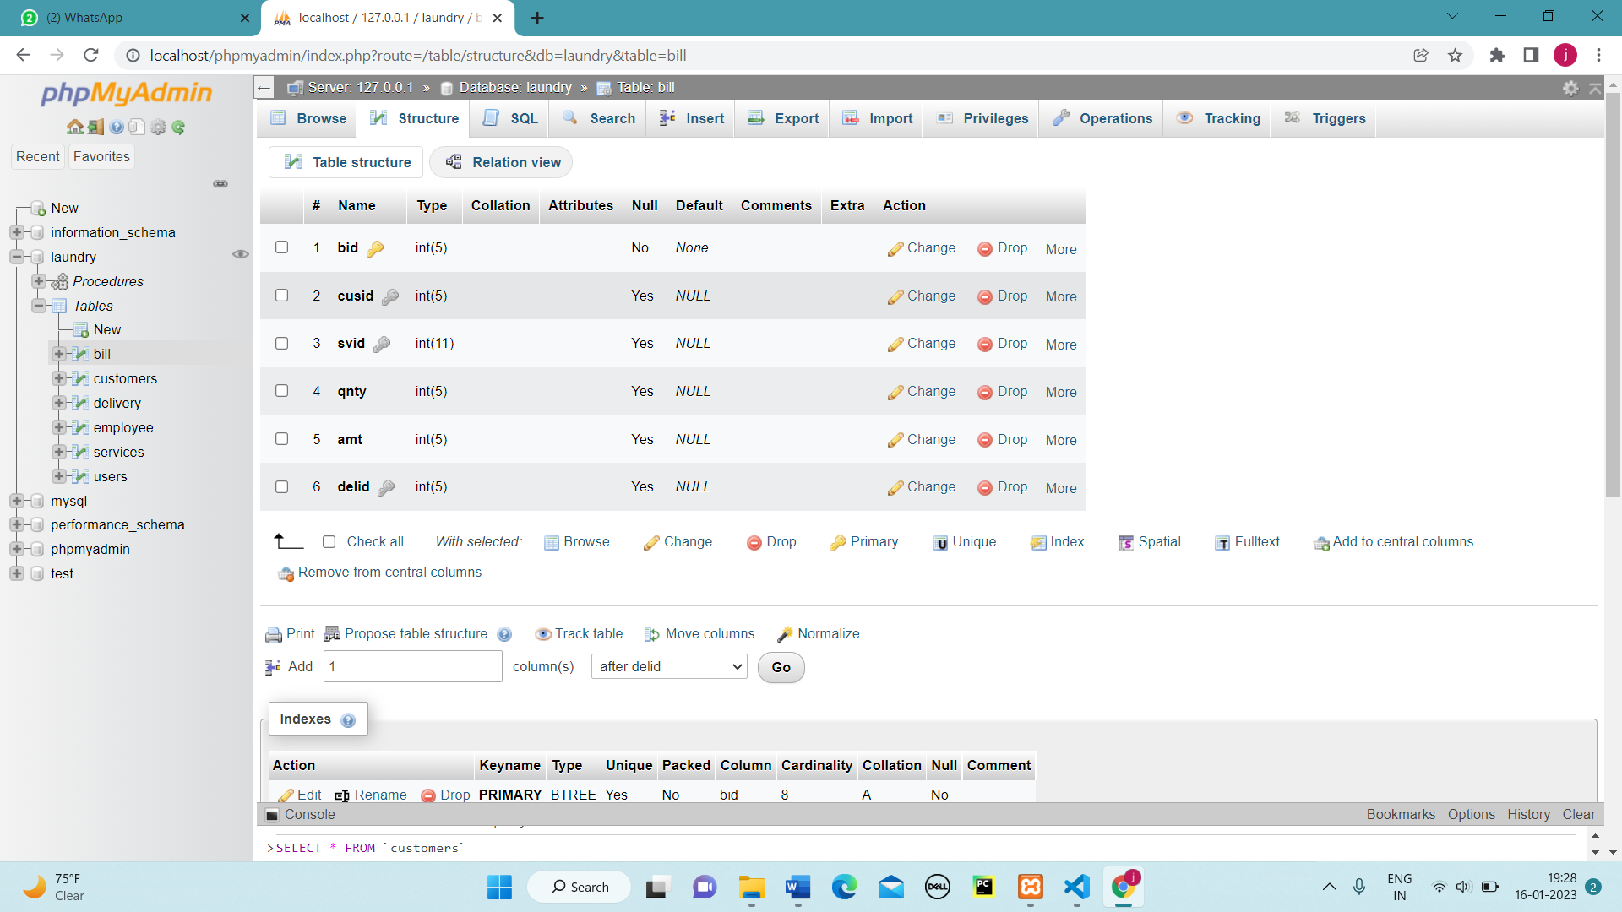

Figure 4.2.4- Description of Bill

SQL->Desc delivery;

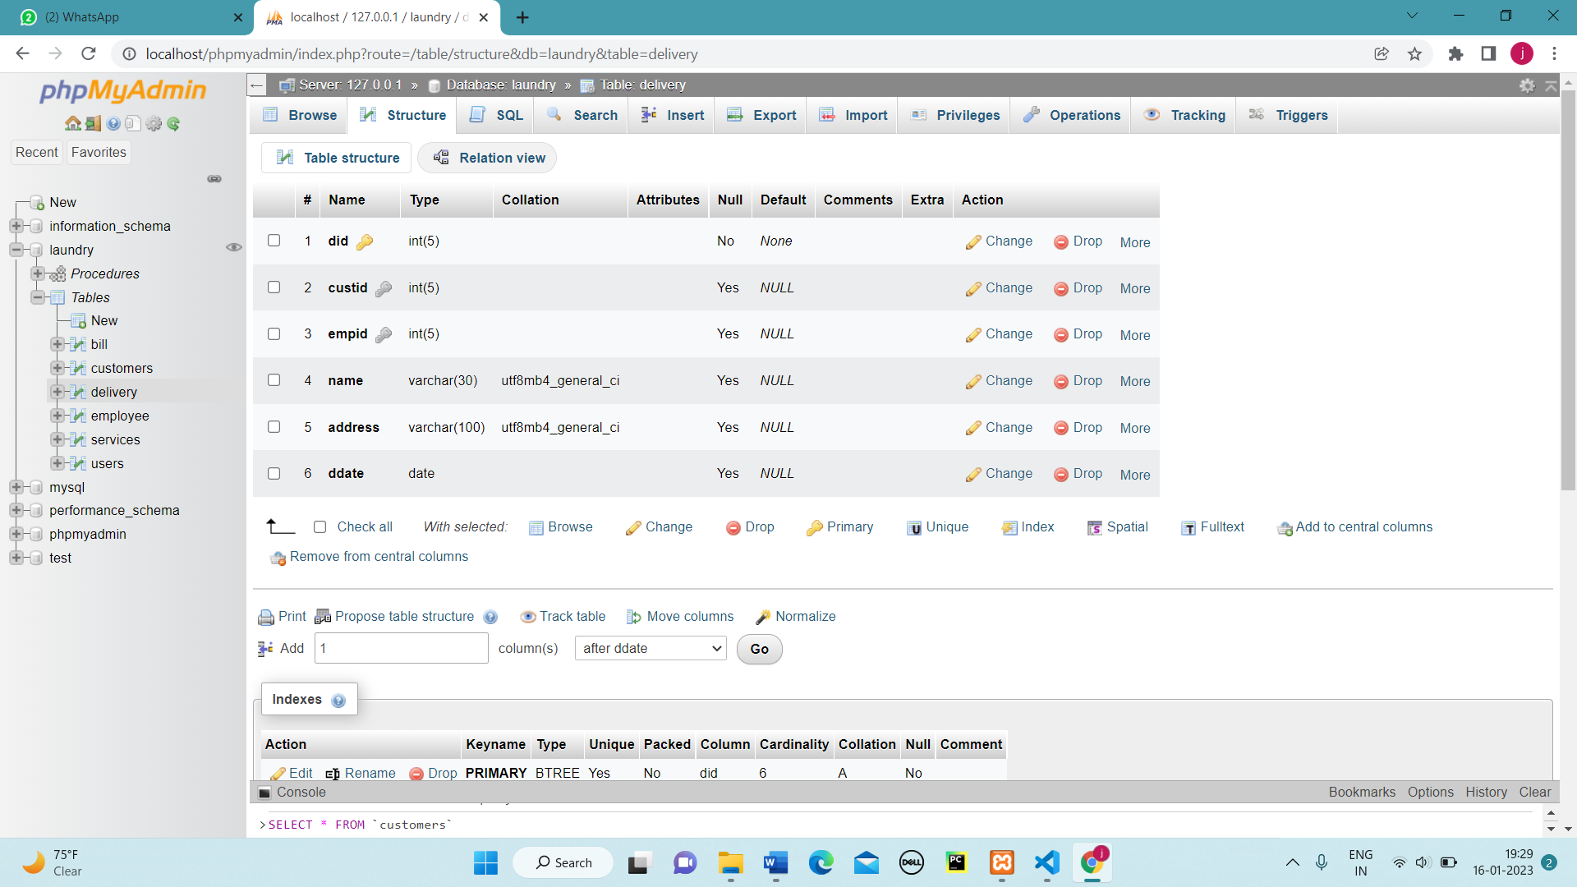

Figure 4.2.5- Description of Delivery

* 1. **POPULATED TABLES**

SQL->SELECT * FROM CUSTOMERS;

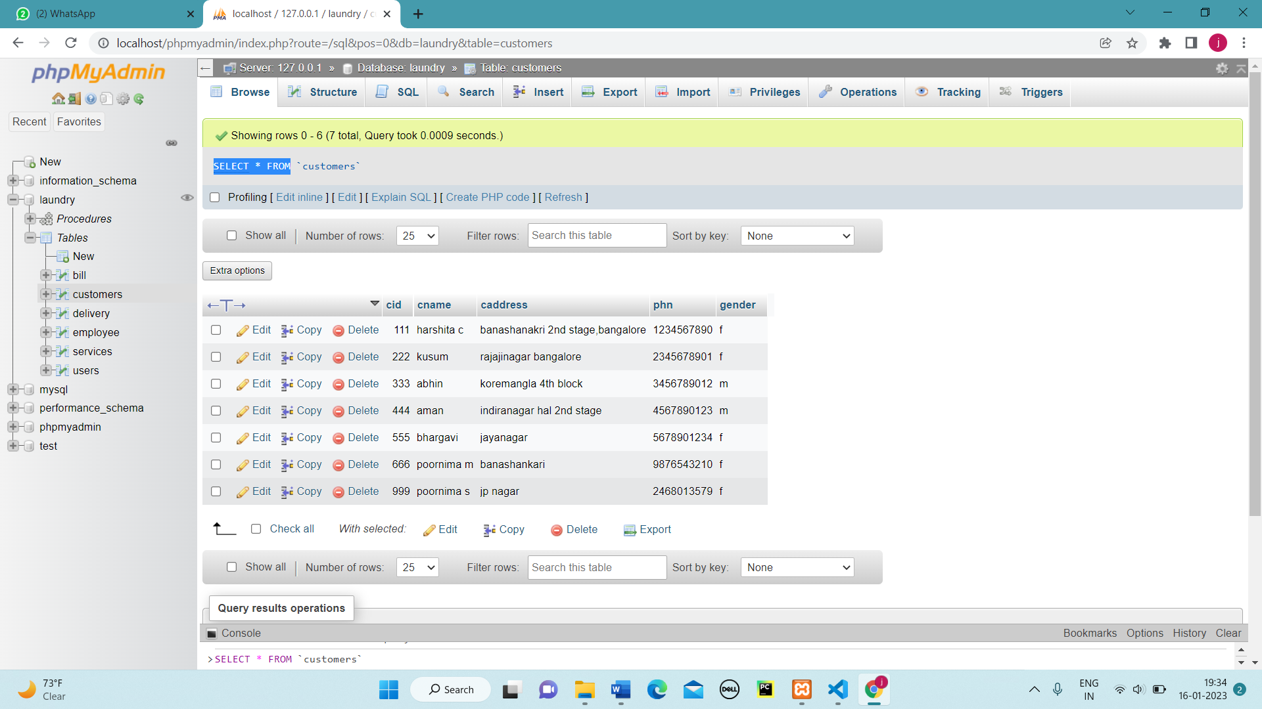

Figure 4.3.1-View of Customer

SQL->SELECT * FROM EMPLOYEE;

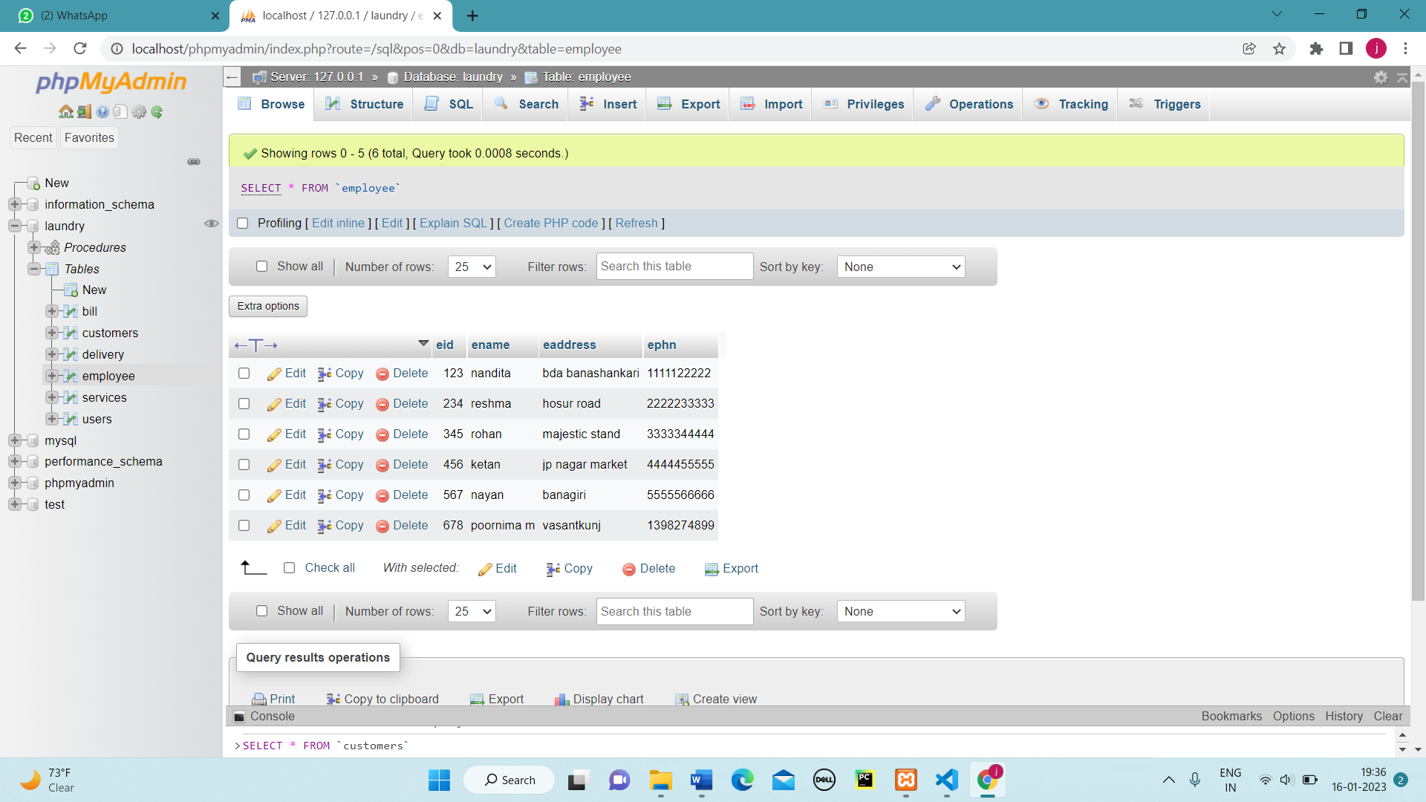

Figure 4.3.2-View of Employee

SQL->SELECT * FROM SERVICES;

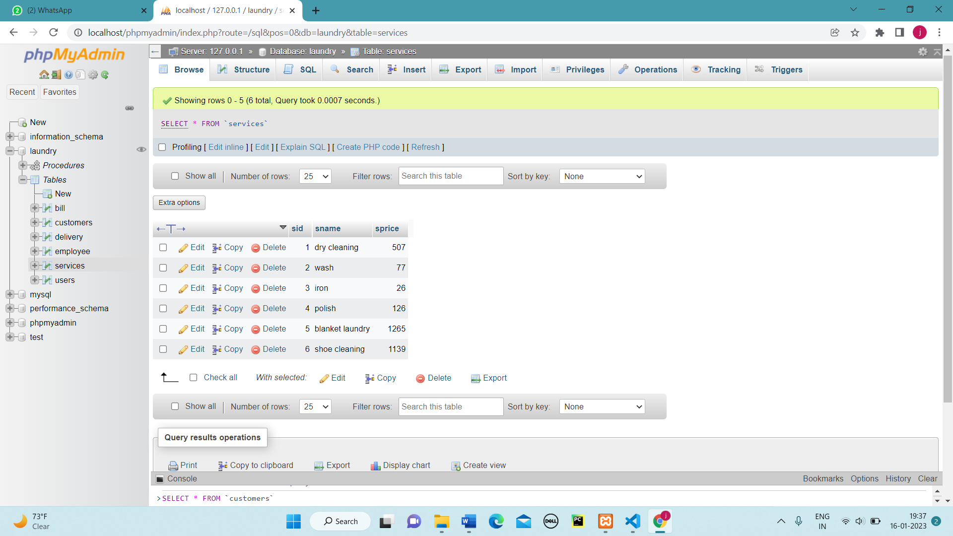

Figure 4.3.3-View of Services

SQL->SELECT * FROM DELIVERY;

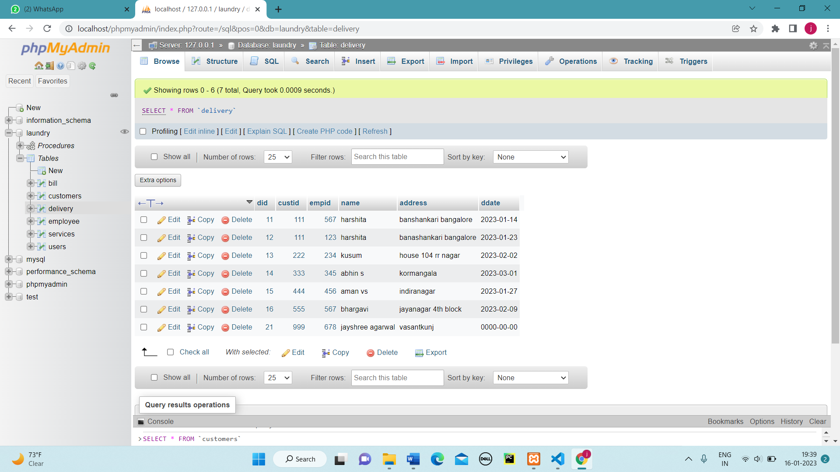

Figure 4.3.4-View of Delivery

SQL->SELECT * FROM BILL;

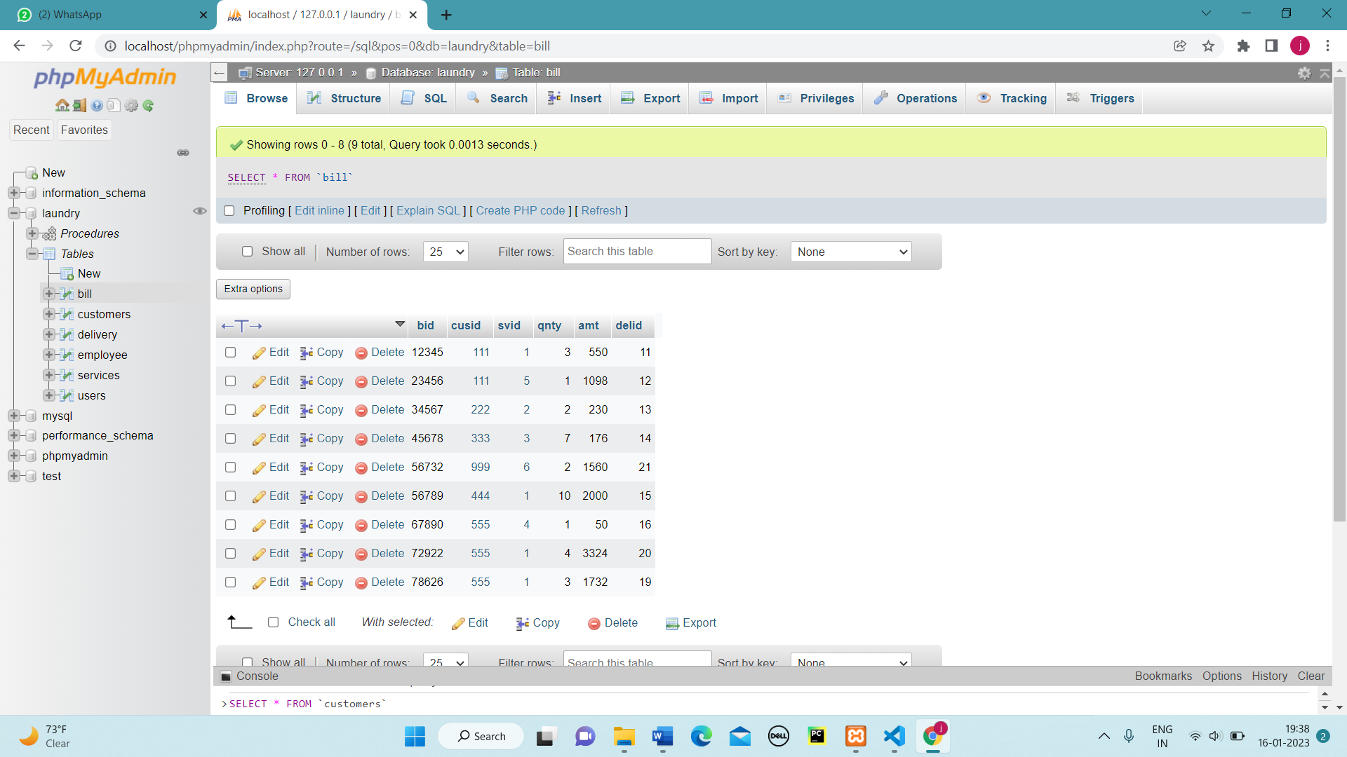

Figure 4.3.5-View of Bill

* 1. **SQL TRIGGERS AND STORED PROCEDURES**
* Trigger 1

CREATE TRIGGER `insertintouser` AFTER INSERT ON `employee` FOR EACH ROW INSERT INTO users VALUES (new.eid,concat(new.eid,new.ename));

* Trigger 2

CREATE TRIGGER `deletefromuser` AFTER DELETE ON `employee` FOR EACH ROW DELETE FROM users WHERE id=old.eid;

* Stored Procedure 1

CREATE PROCEDURE `customerhistory` (IN `id` INT) NOT DETERMINISTIC CONTAINS SQL SECURITY DEFINER SELECT c.*, b.bid , b.delid ,d.empid , d.ddate from customers c join bill b on c.cid=b.cusid inner join delivery d on b.delid=d.did where cid=id;

* Stored Procedure 2

CREATE PROCEDURE `updatesprice` (IN `v` INT) NOT DETERMINISTIC CONTAINS SQL SECURITY DEFINER update services set sprice =sprice + (sprice*v)/100;

* 1. **DATABASE CONNECTIVITY**

<?php

function OpenCon(){

$dbhost = "localhost";

$dbuser = "root";

$dbpass = "";

$db = "laundry";

$conn = new mysqli($dbhost, $dbuser, $dbpass,$db) or die("Connect failed: %s\n". $conn -> error);

return $conn; }

function CloseCon($conn){

$conn -> close();}

?>

**Chapter 5**

1. **RESULTS**

**LOGIN TAB:**

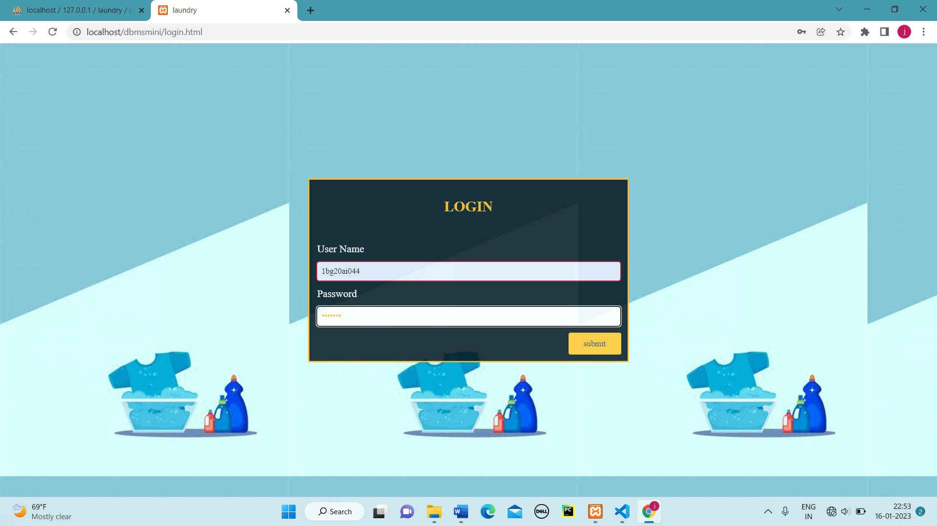

Figure 5.1- Login Tab

**HOMEPAGE:**

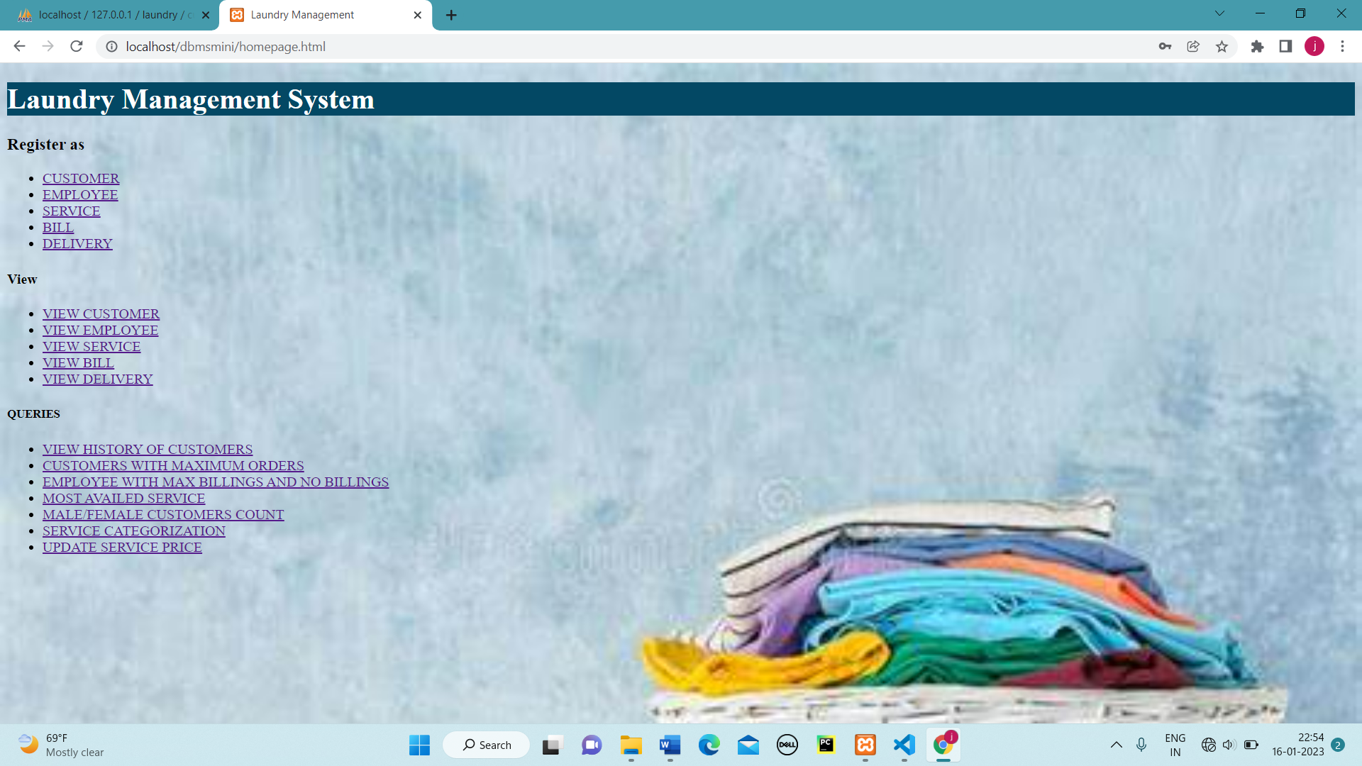

Figure 5.2-Homepage

**CUSTOMER REGISTRATION:**

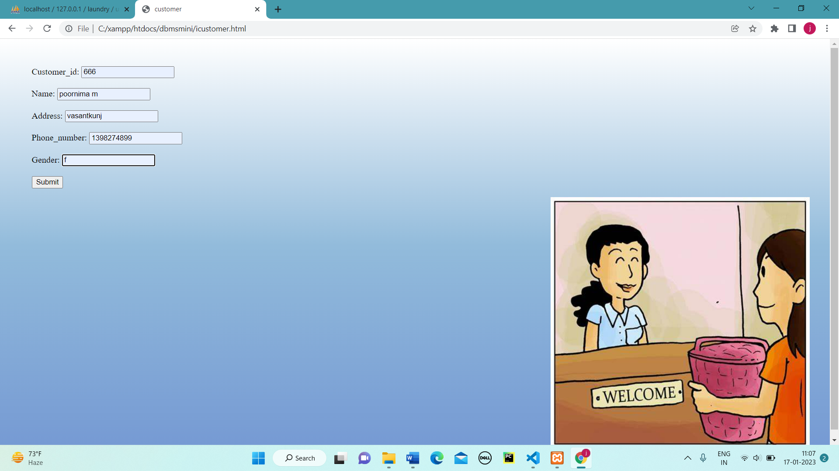

Figure 5.3-Customer Regitration

**DELIVERY DETAILS :**

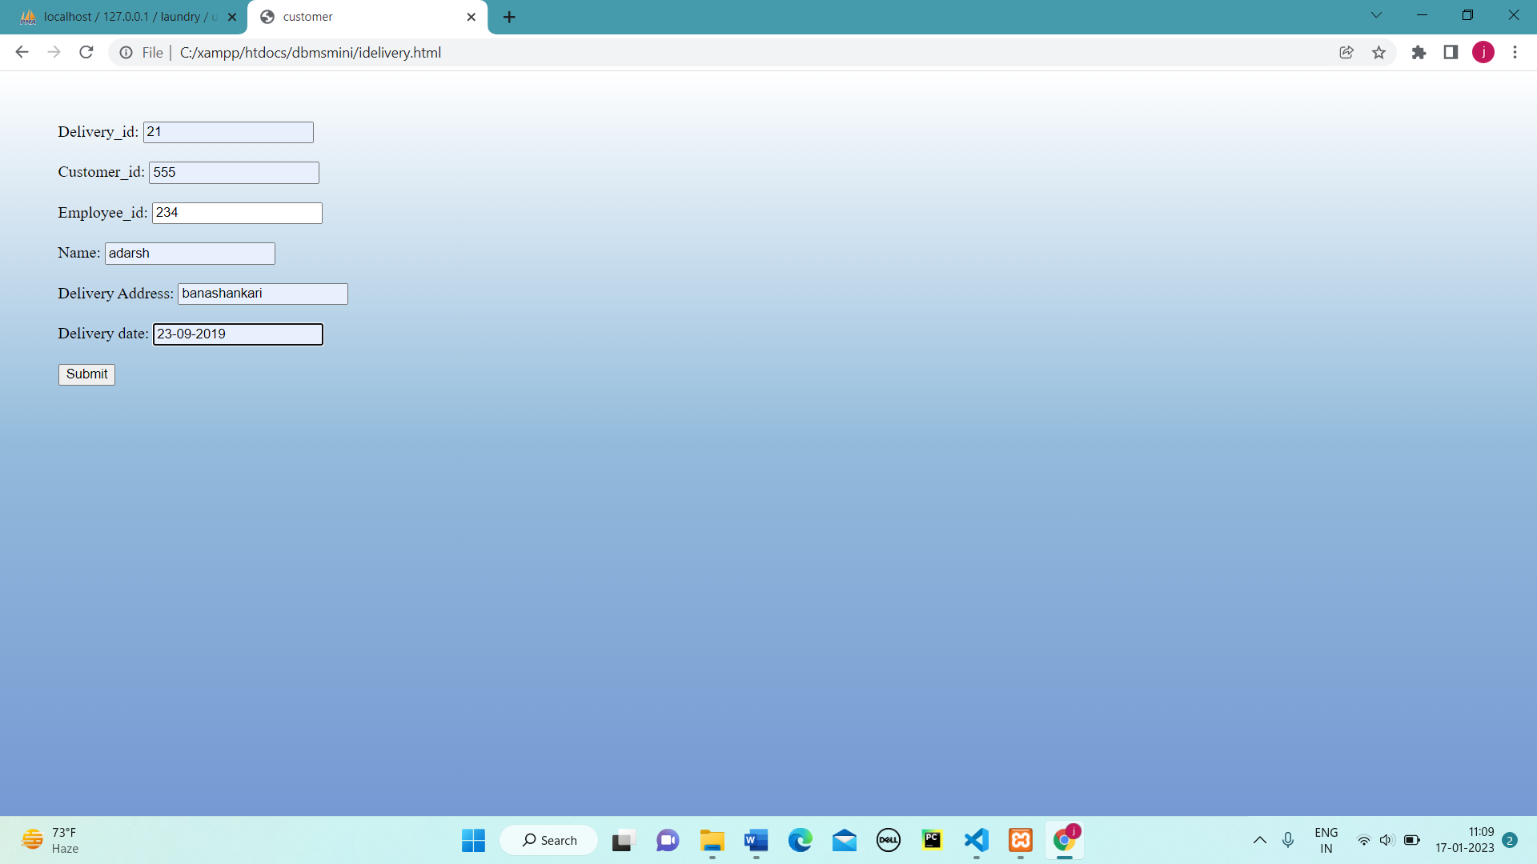

Figure 5.4-Delivery Details

**SERVICE REGISTRATION:**

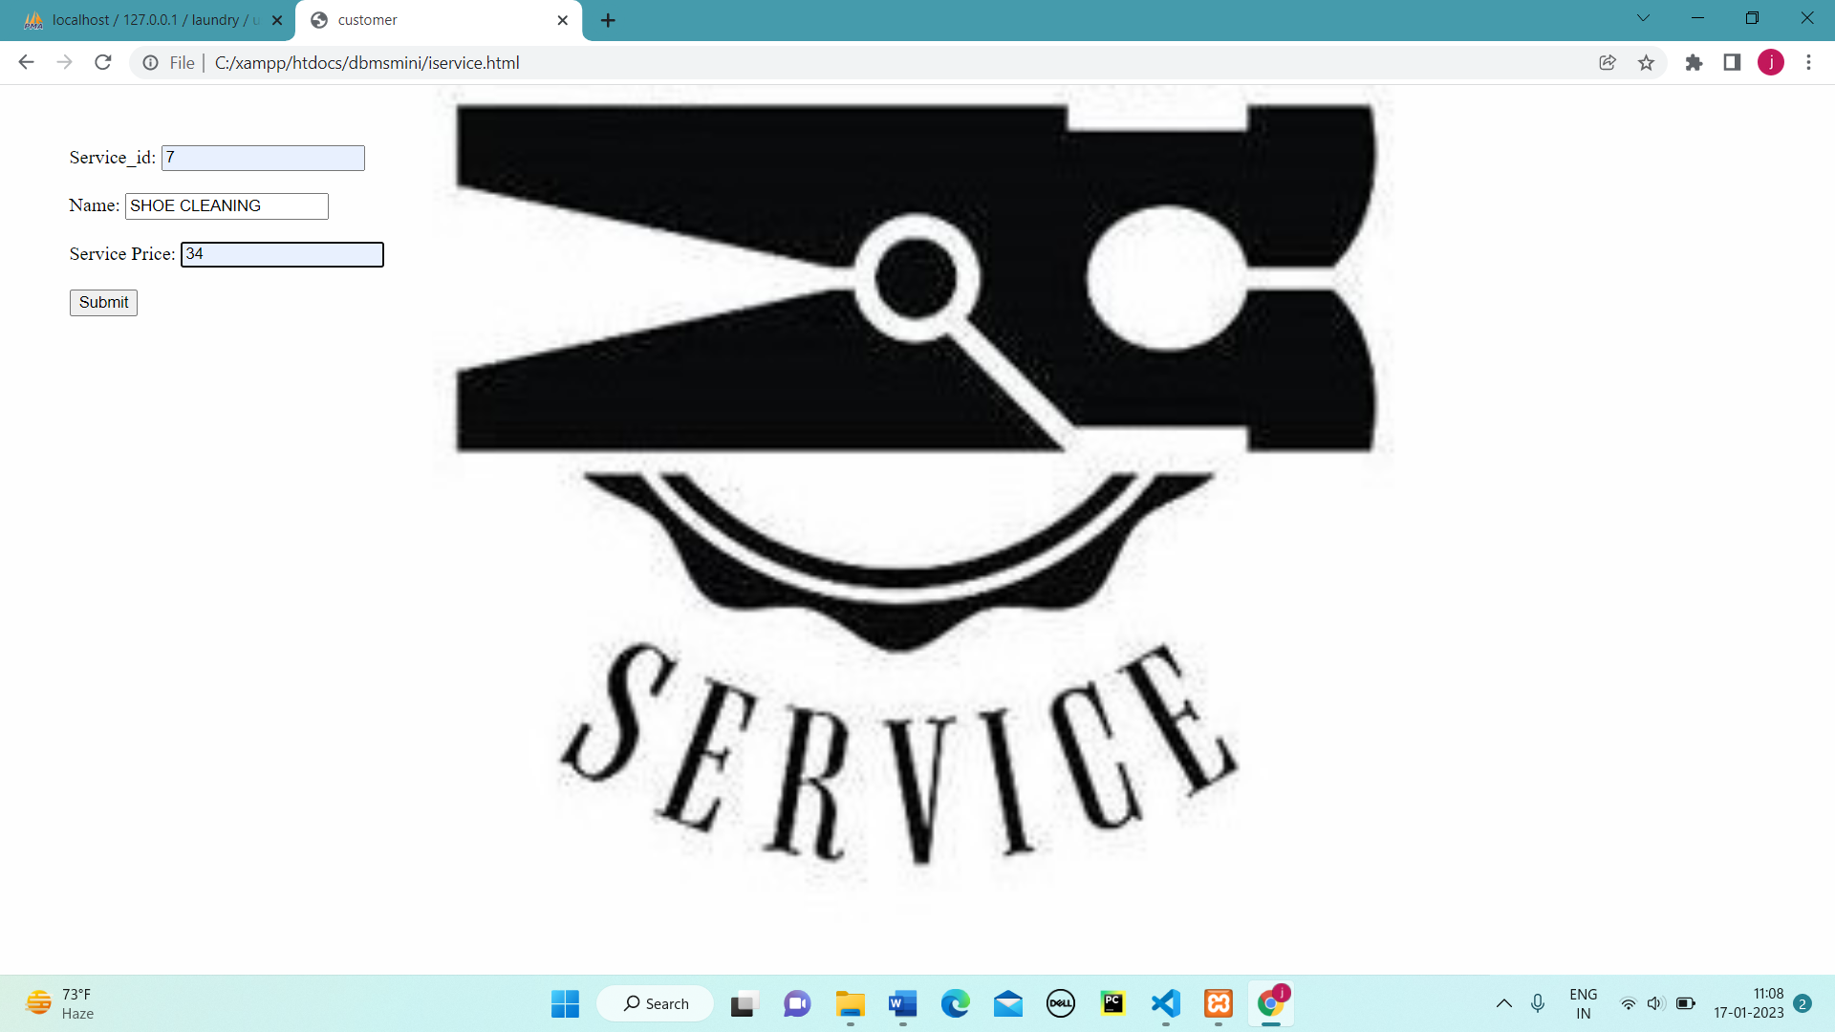

Figure 5.5-Service Registration

**EMPLOYEE REGISTRATION:**

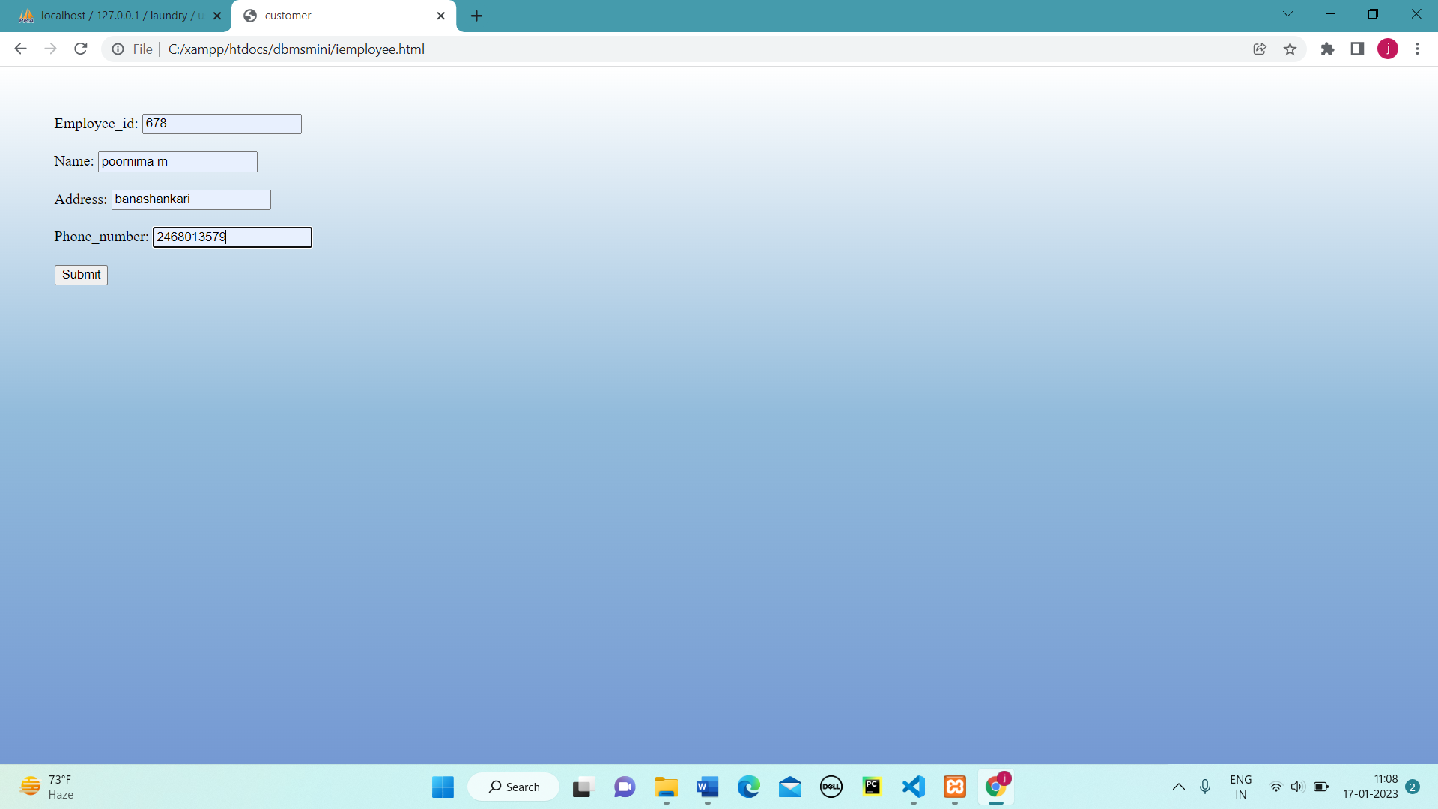Figure 5.6-Employee Registration

**BILL GENERATION:**

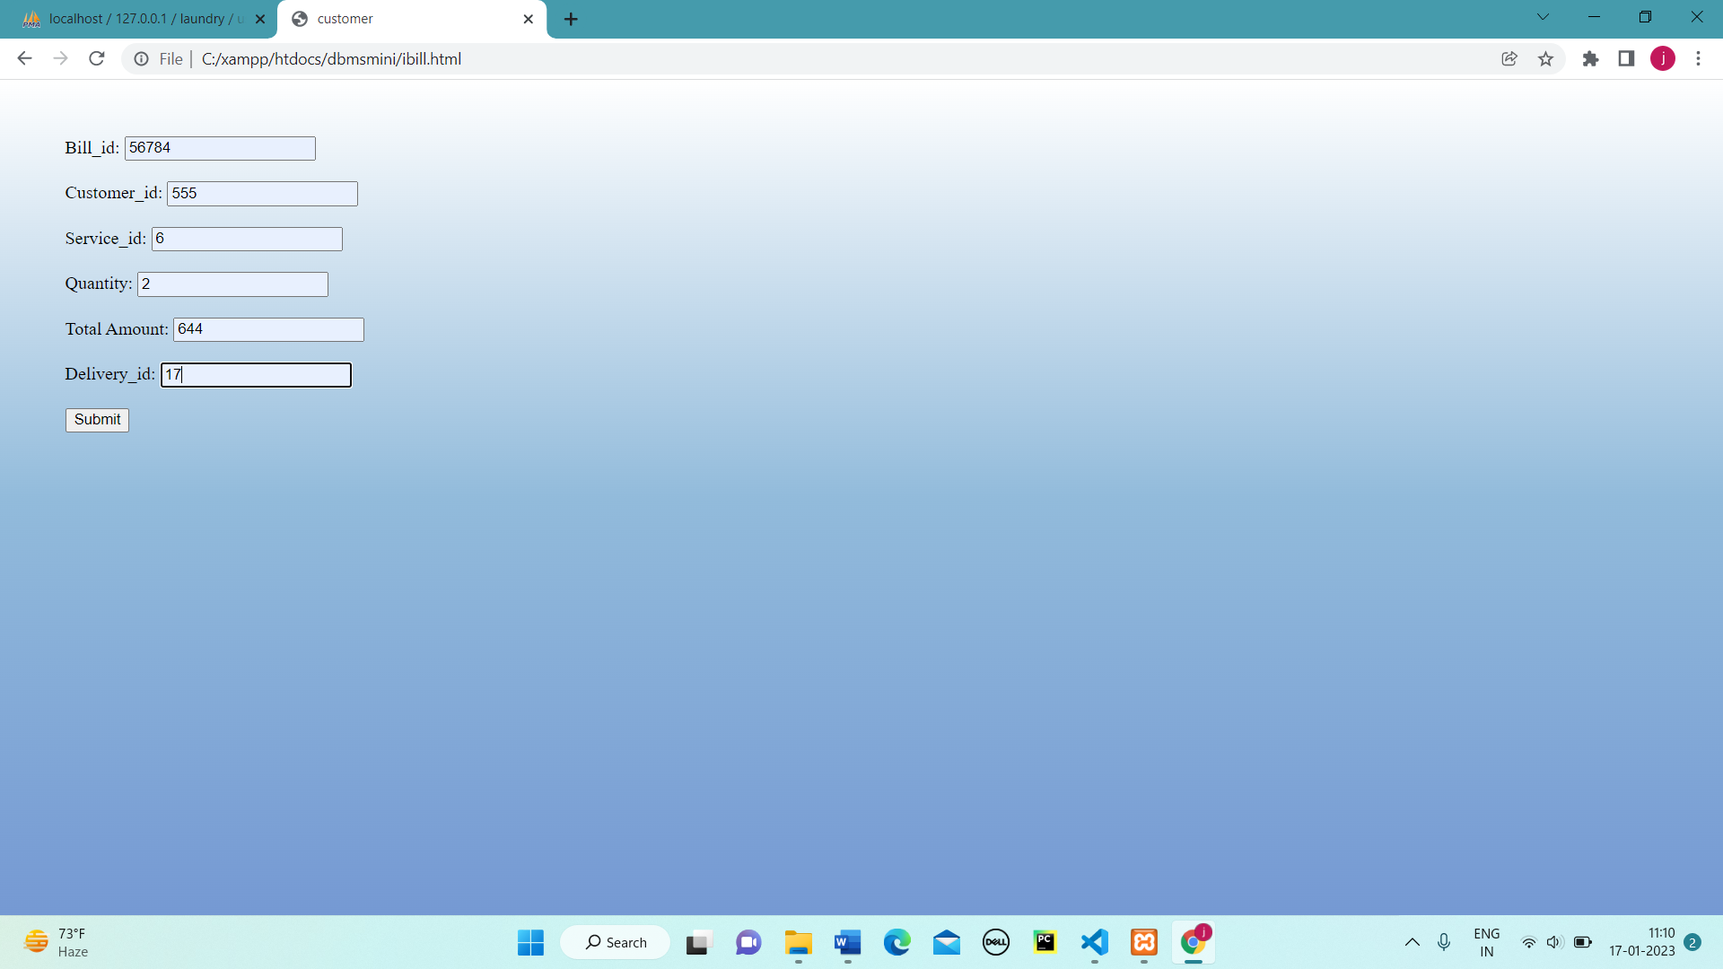

Figure 5.7-Bill Generation

**VIEW CUSTOMERS:**

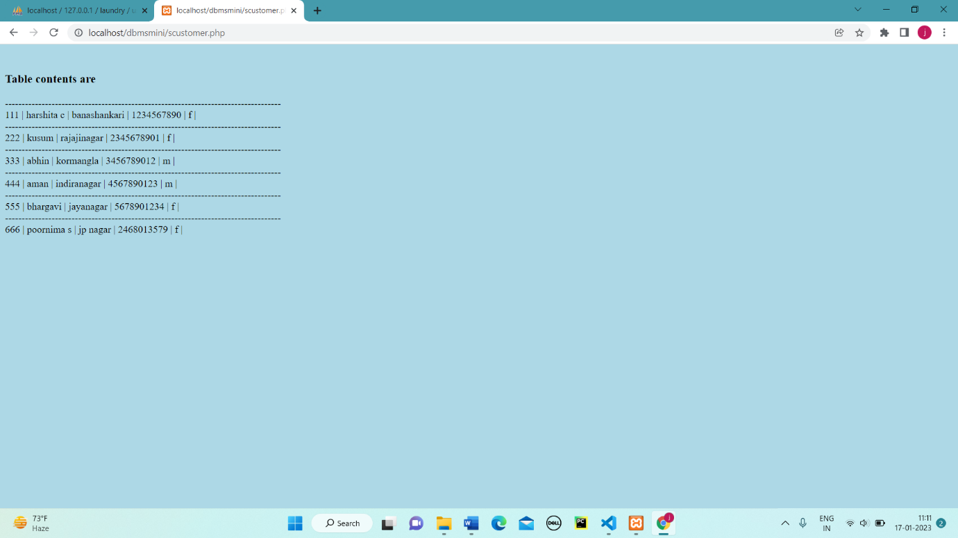Figure 5.8-View Customers

**VIEW EMPLOYEE:**

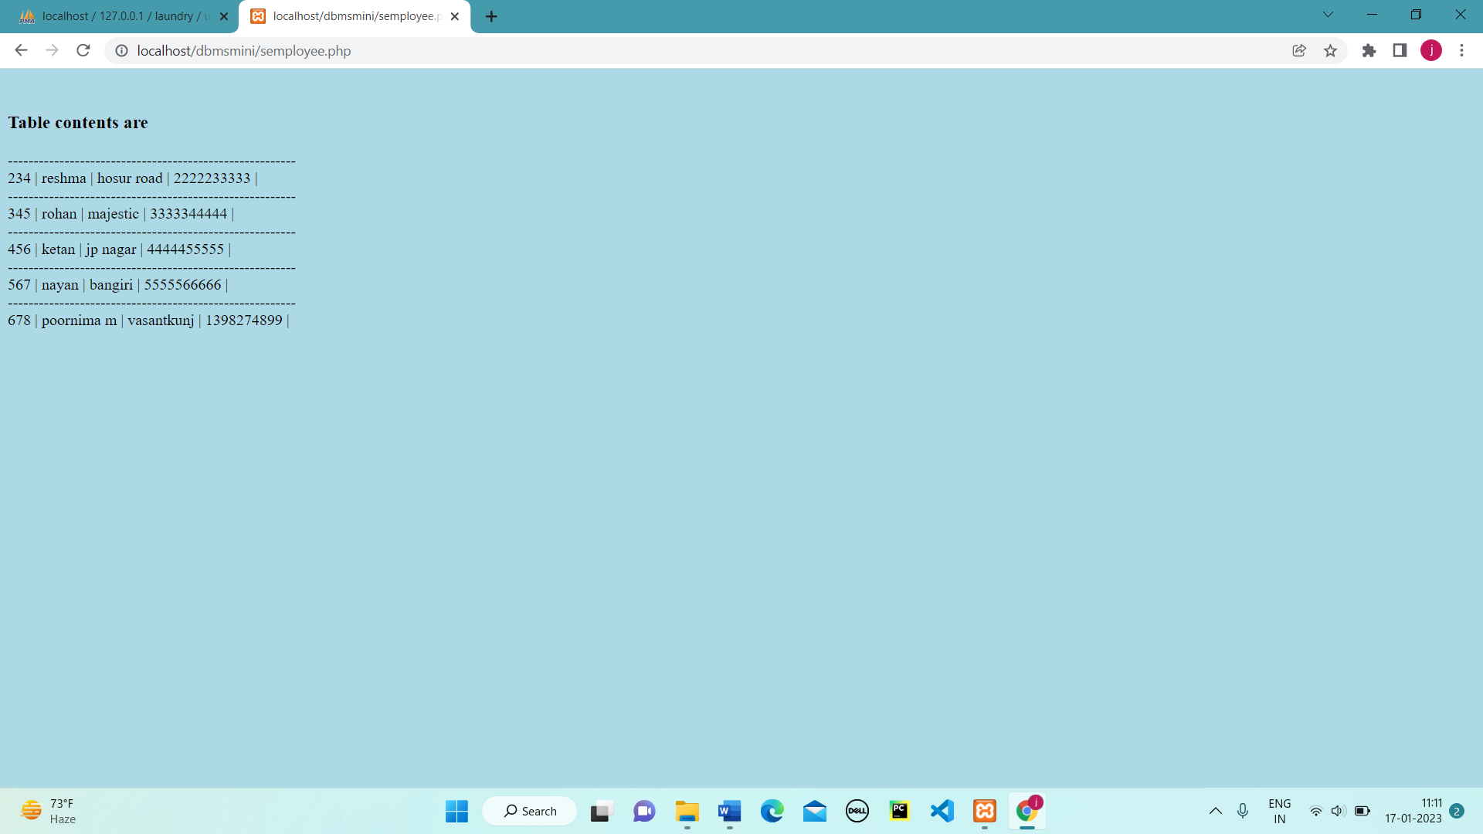

Figure 5.9-View Employee

**VIEW SERVICES:**

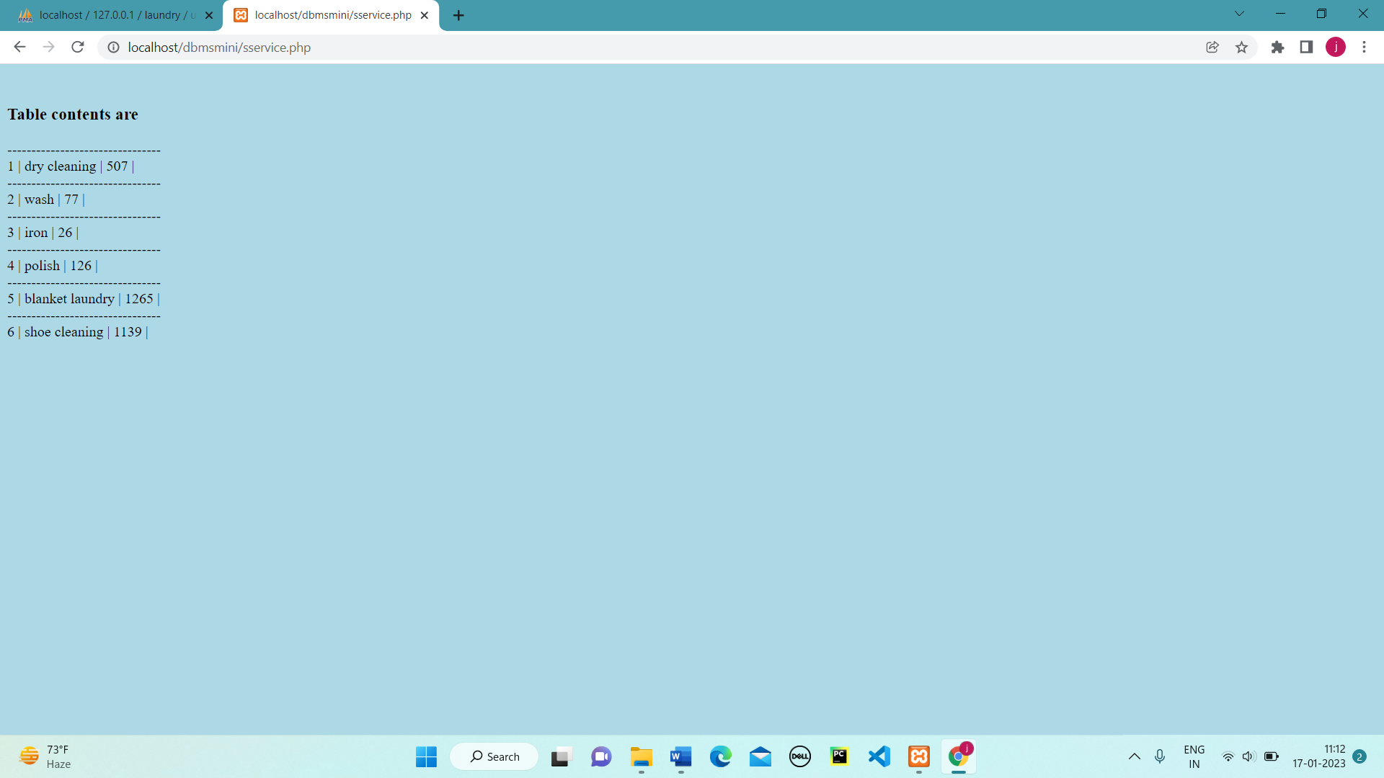

Figure 5.10-View Services

**VIEW BILLS:**

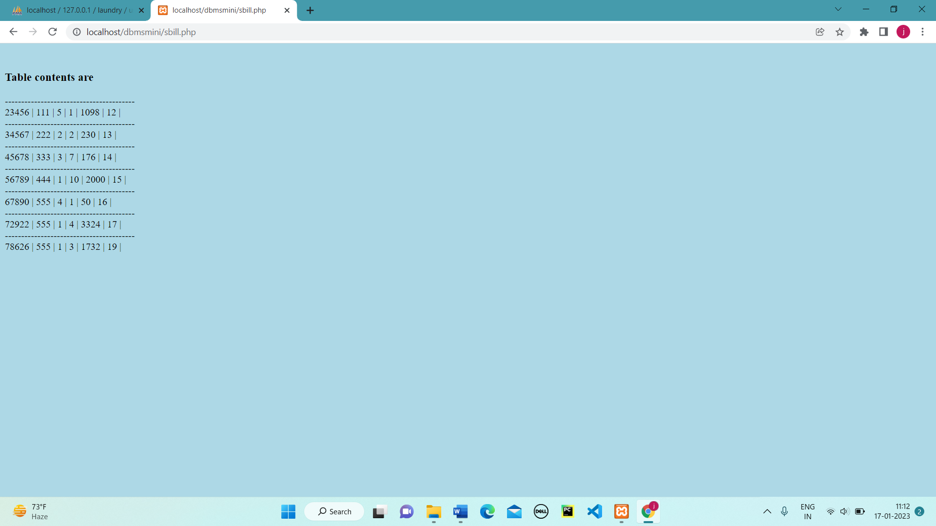

Figure 5.11-View Bills

**VIEW DELIVERIES:**

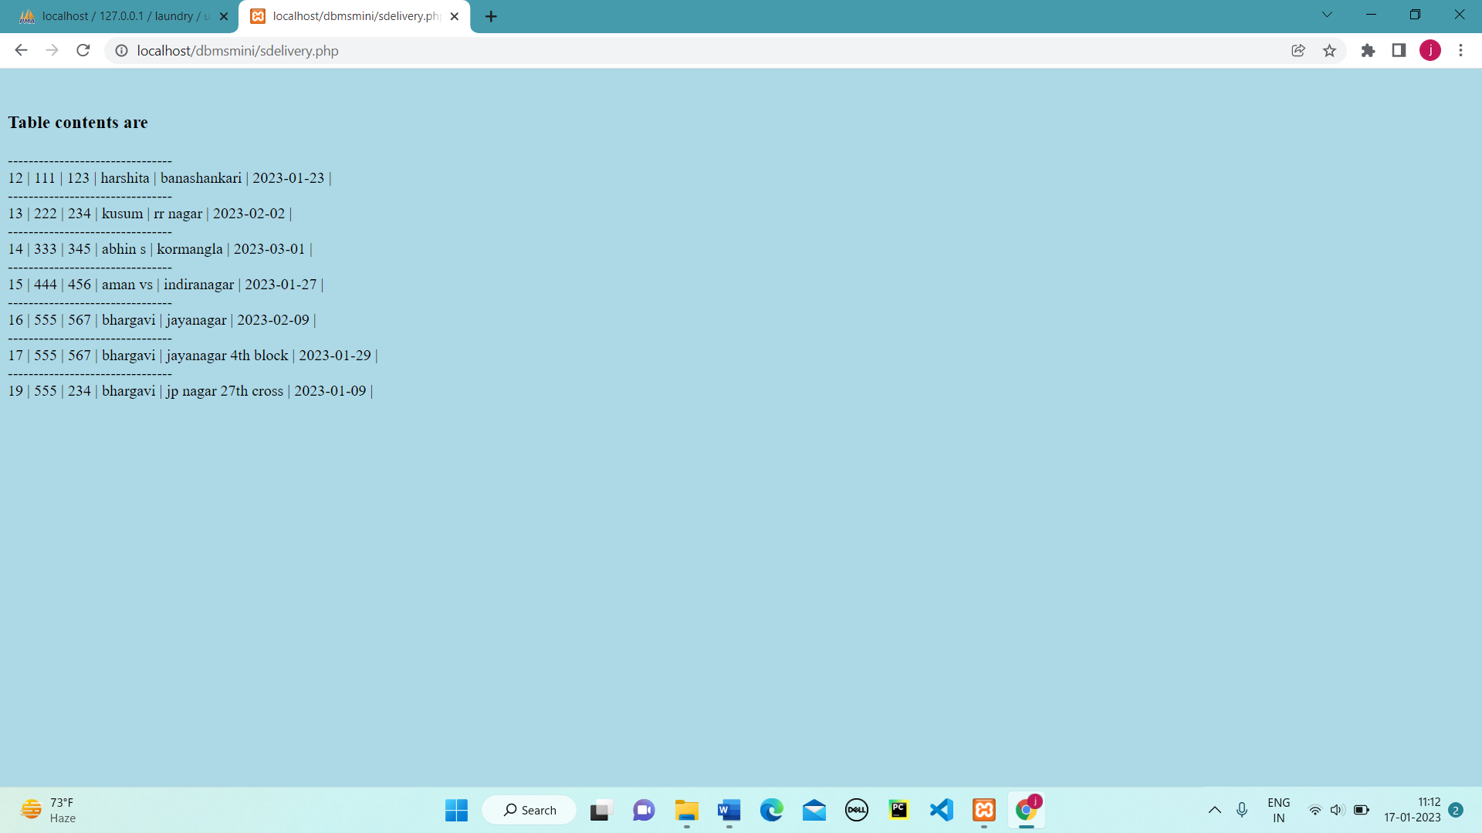

Figure 5.12-View Deliveries

**CUSTOMER WITH MAX ORDERS:**

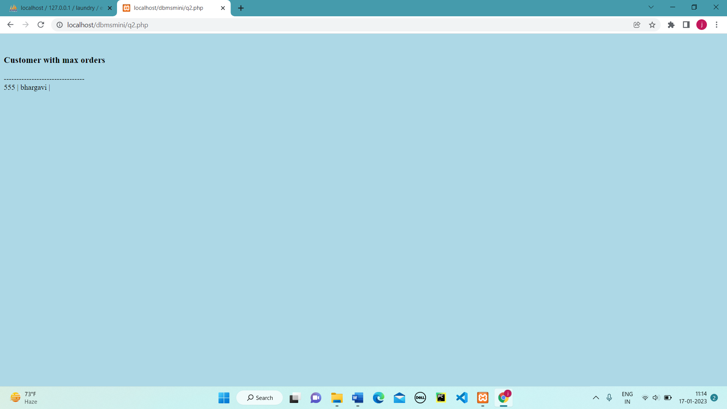

Figure 5.13-Customer with max orders

**VIEW CUSTOMER HISTORY:**

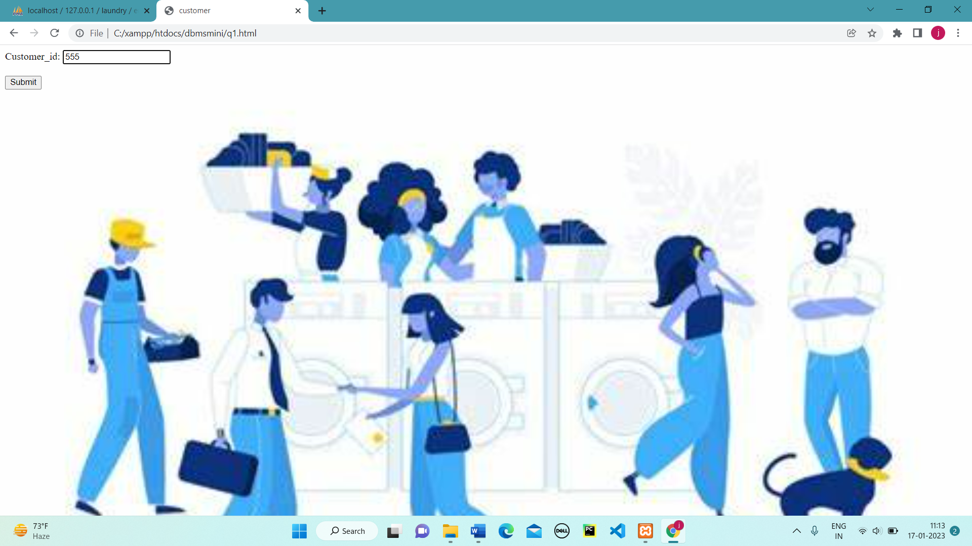 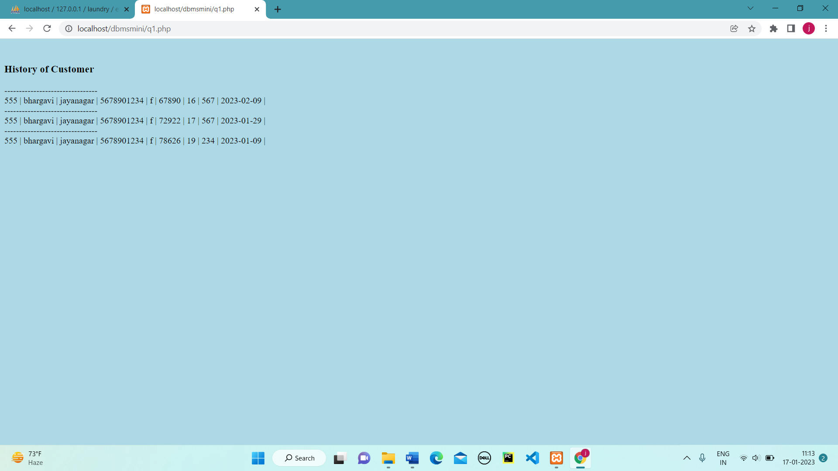

Figure 5.14-View Customer History Figure 5.15-View Customer History

**MAX BILLINGS OF EMPLOYEE:**

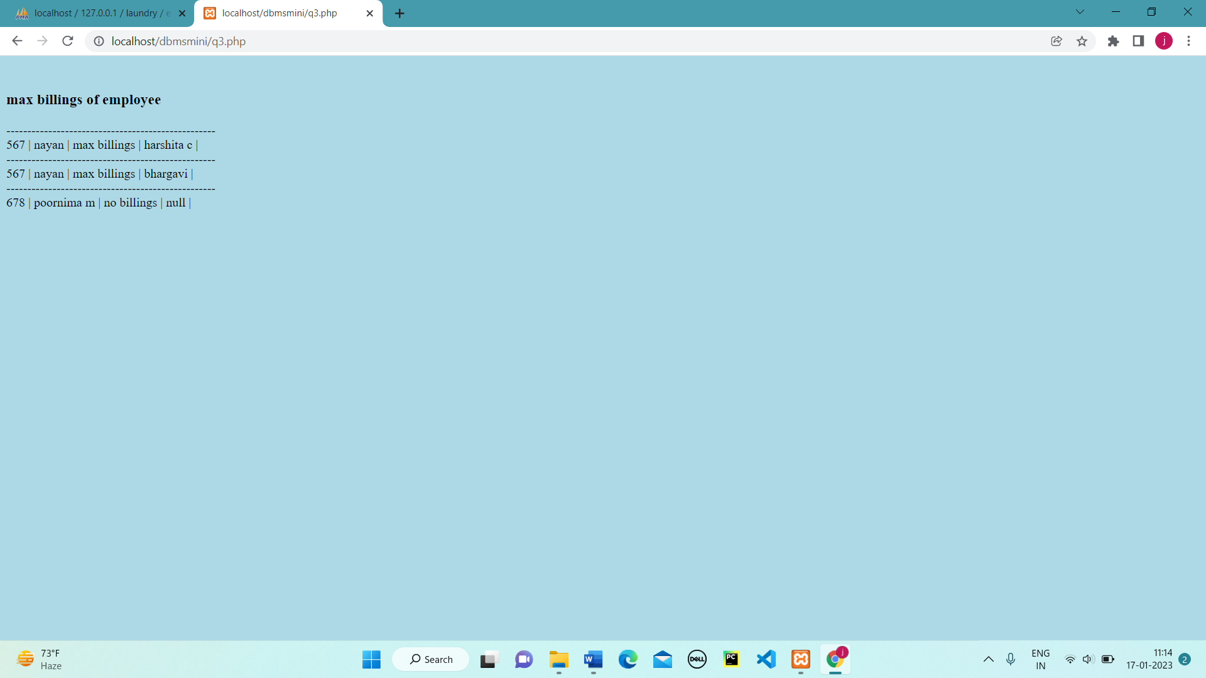

Figure 5.16-Max Billings Of Employee

**MOST AVAILED SERVICE:**

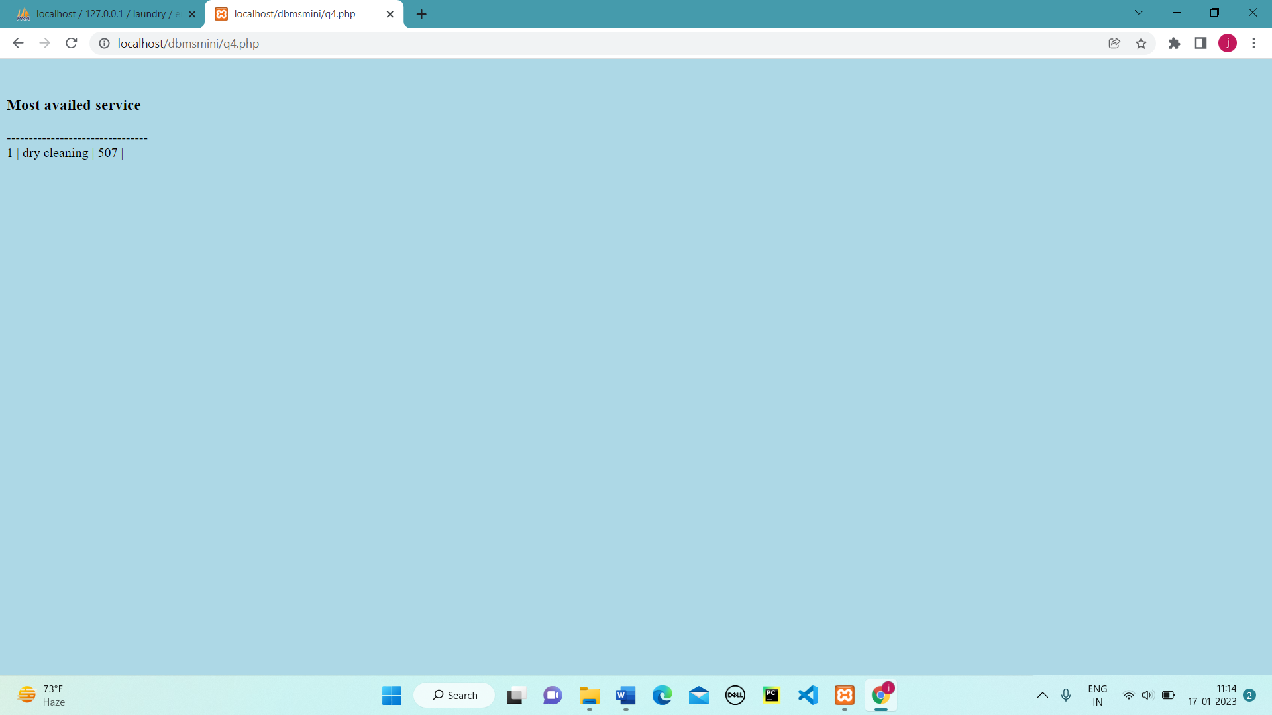

Figure 5.17-Most Availed Service

**MALE/FEMALE CUSTOMER COUNT:**

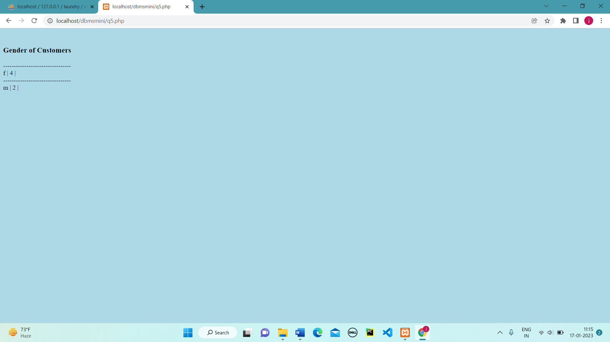

Figure 5.18-Male/Female Customer Count

**SERVICE CATEGORIZATION:**

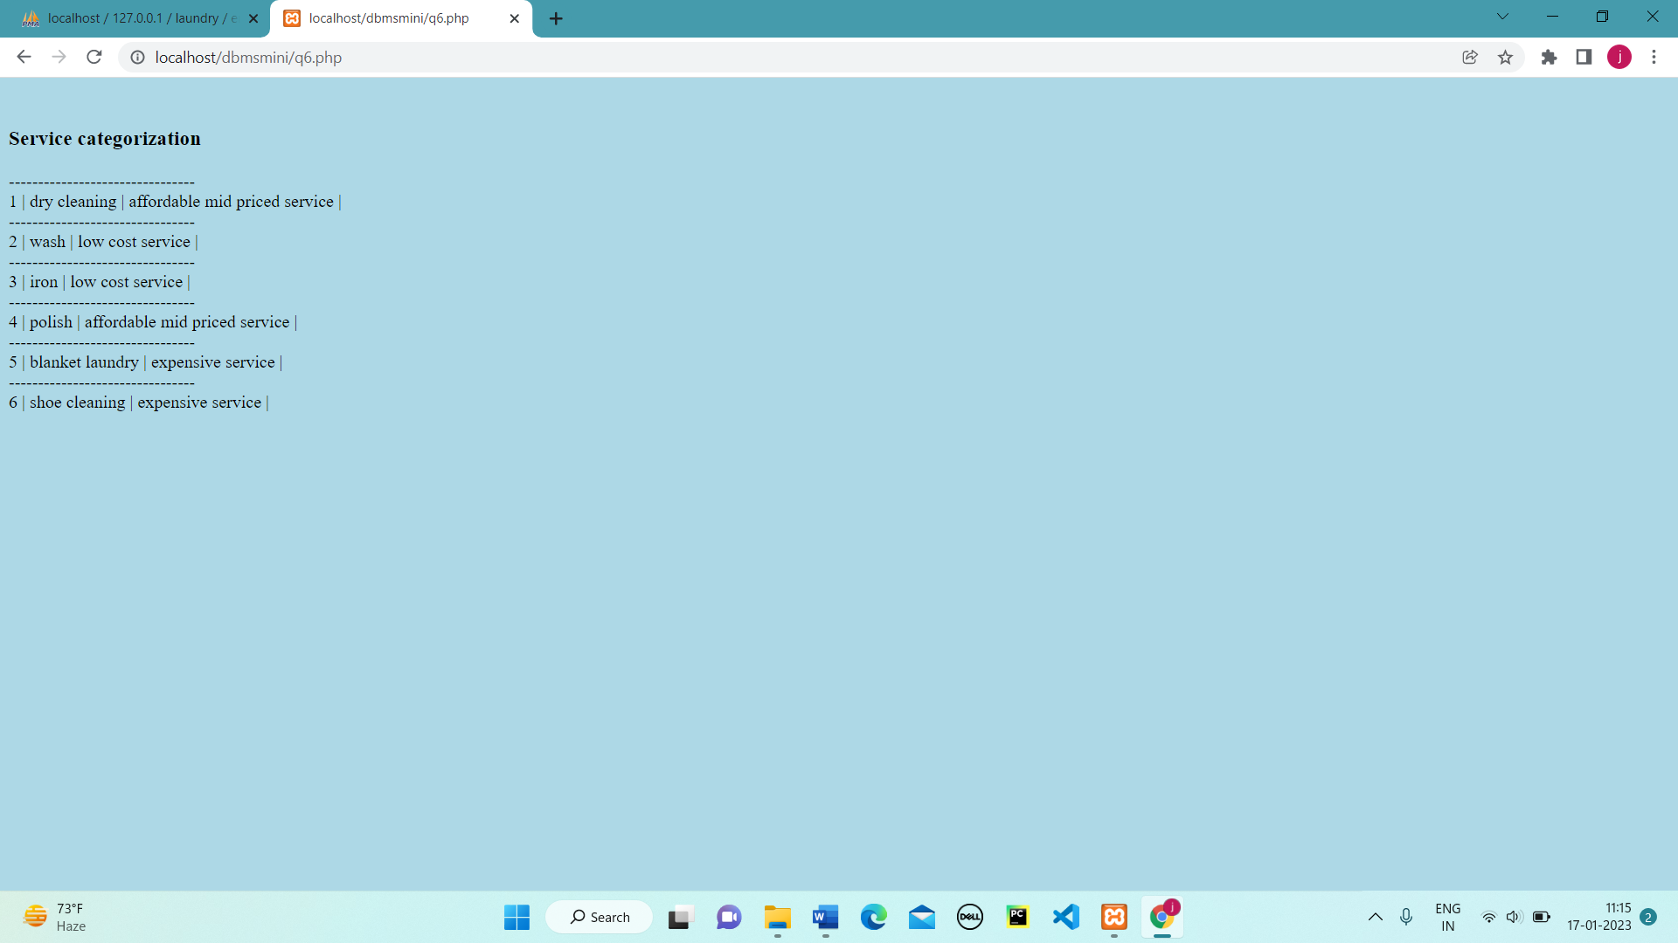

Figure 5.19-Service Categorization

**SERVICE PRICE UPDATE:**

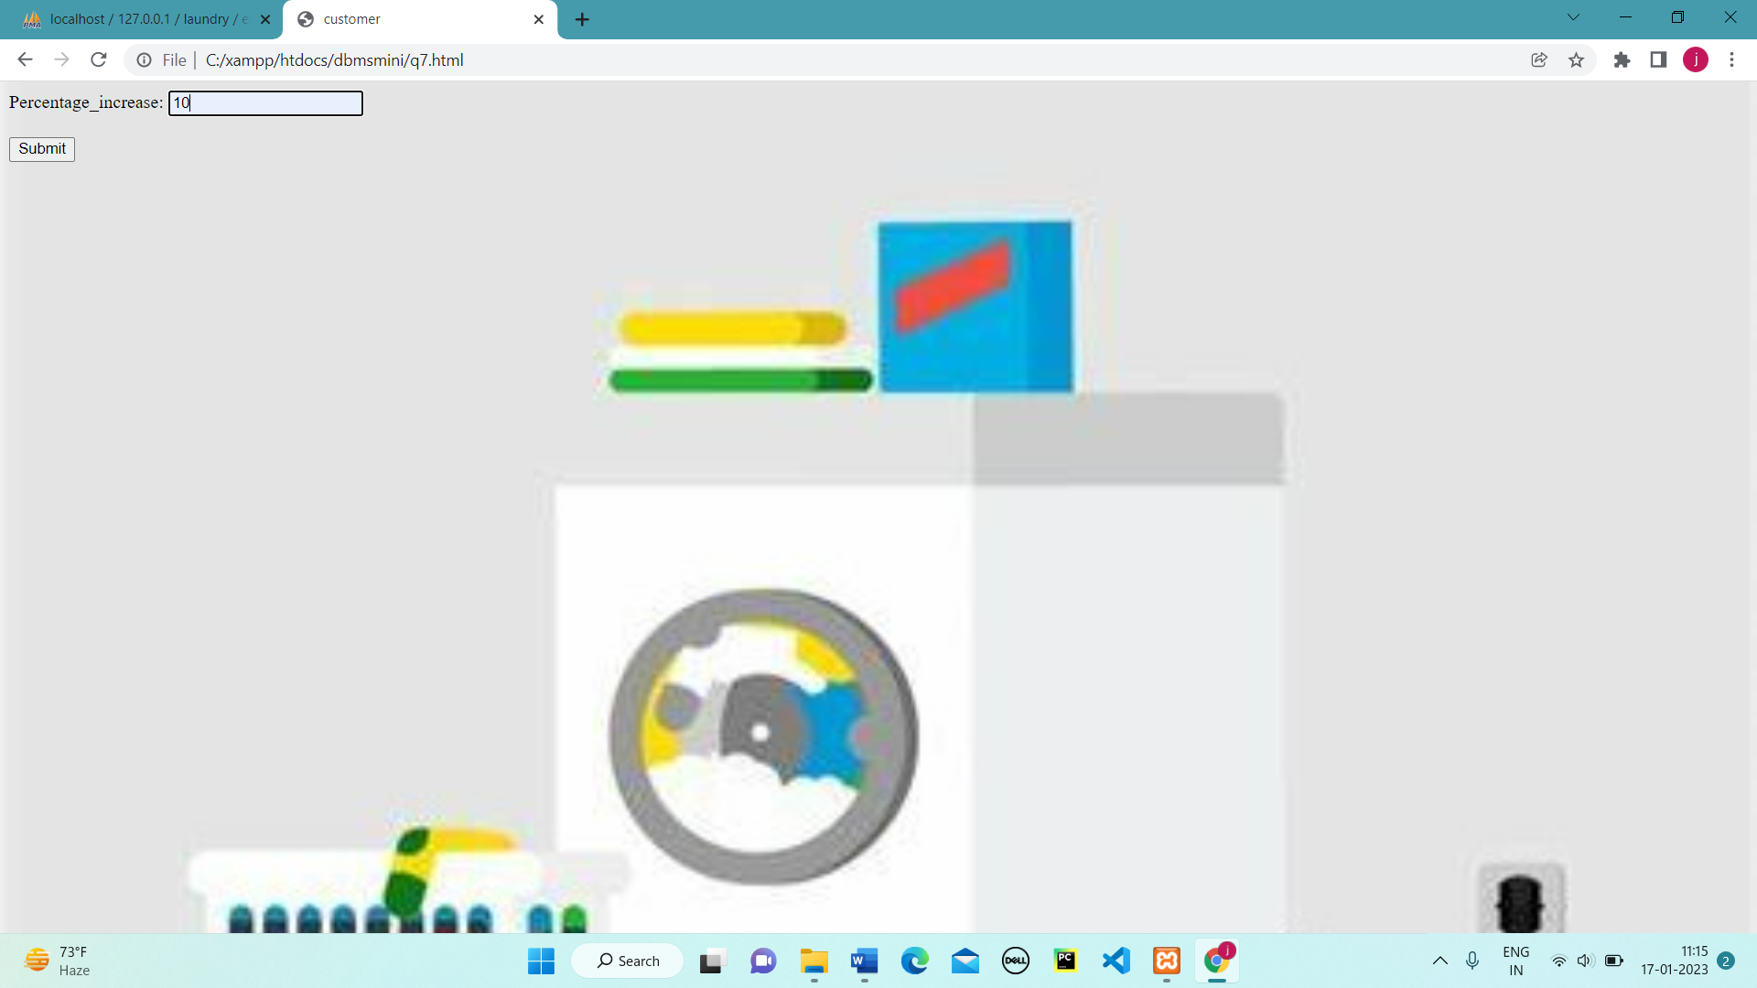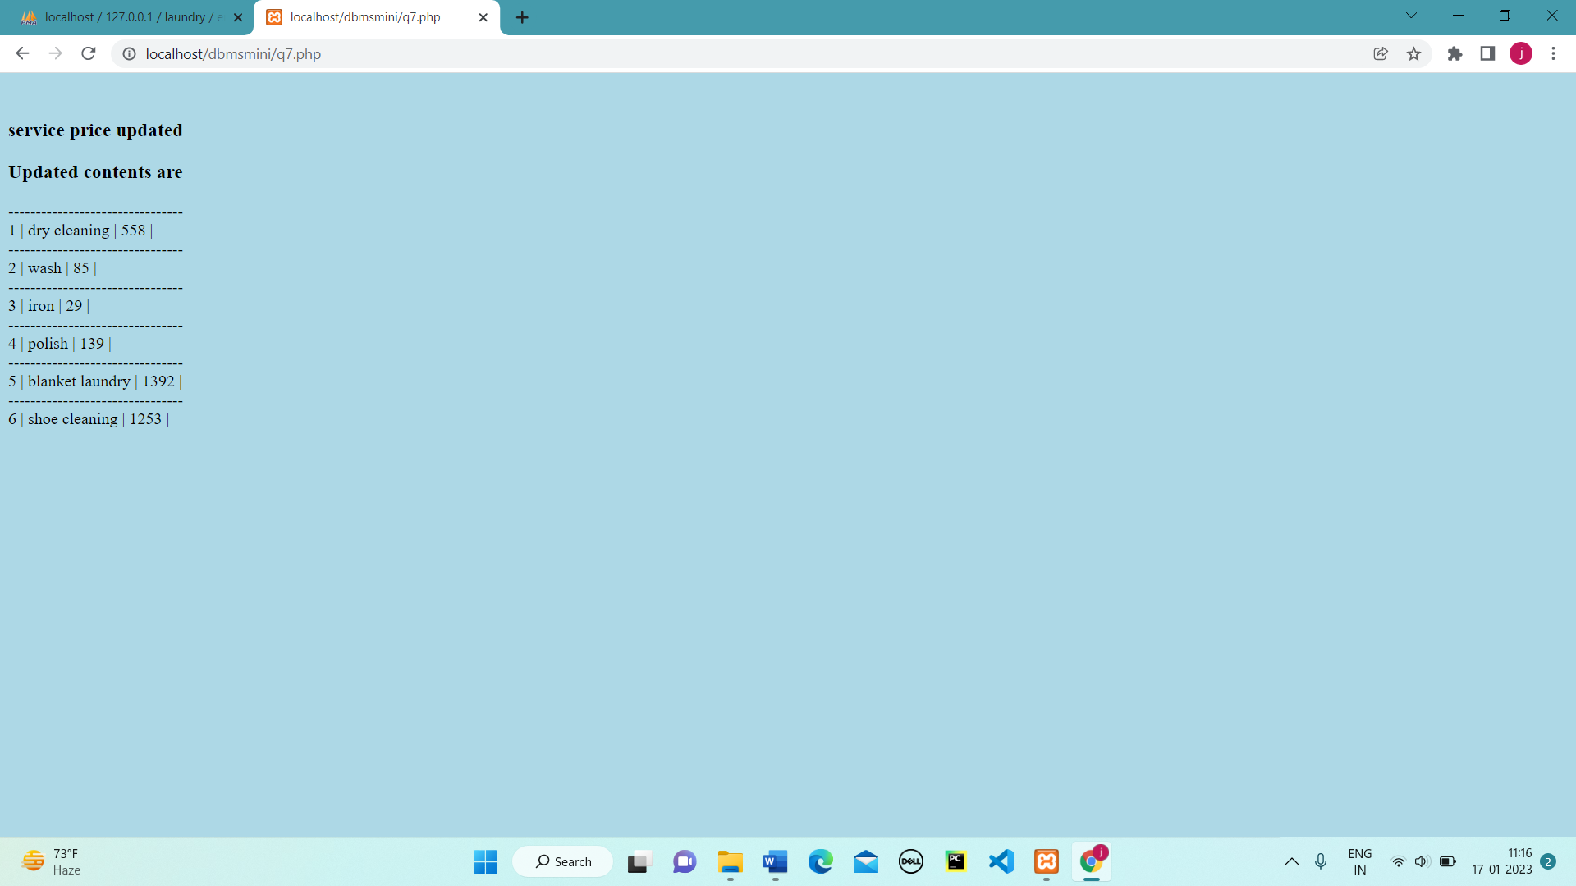

Figure 5.20-Service Price Update Figure 5.21- Service Price Update

**Chapter 6**

1. **CONCLUSION & FUTURE ENHANCEMENTS**

**Conclusion:**

APPLICATION Laundry System play an important role in the process of collecting clothes and managing cloth stocks, approving service requests, updating deliveries and transactions and updating available service types. List the availability of certain services at any given time.

• Ability to manage the information of its customer.

• Alerts for service requirement from registered users.

• Auto-check for the orders of the person in the last few months.

• Allows good documentation about the user and their service activities and billing transactions.

• Proper information of availability of service, according to users need and the delivery

required them.

• Support fast searching to find match employee for providing service to user

**Future Enhancement:**

The system is used for maintaining all the process and activities of laundry management system. The system can be extended to be used for maintaining records of laundry, service availing and other similar sectors. While developing the system, there shall be space for further modification. There shall be a proper documentation so that further enhancement becomes easy. As a whole the system is focused to work with laundry management system and on additional modification it can be also used as management systems of similar organizations